
RCS-2000 API

Developer Guide

Legal Information

© 2023 Hangzhou Hikrobot Co., Ltd. All rights reserved.
This Document (hereinafter referred to be "the Document") is the property of Hangzhou Hikrobot Co., Ltd. or its affiliates (hereinafter referred to as "Hikrobot"), and it cannot be reproduced, changed, translated, or distributed, partially or wholly, by any means, without the prior written permission of Hikrobot. Unless otherwise expressly stated herein, Hikrobot does not make any warranties, guarantees or representations, express or implied, regarding to the Document, any information contained herein.

LEGAL DISCLAIMER
TO THE MAXIMUM EXTENT PERMITTED BY APPLICABLE LAW, THE DOCUMENT IS PROVIDED "AS IS" AND "WITH ALL FAULTS AND ERRORS". HIKROBOT MAKES NO REPRESENTATIONS OR WARRANTIES, EXPRESS OR IMPLIED, INCLUDING BUT NOT LIMITED TO, WARRANTIES OF MERCHANTABILITY, FITNESS FOR A PARTICULAR PURPOSE OR NON-INFRINGEMENT. IN NO EVENT WILL HIKROBOT BE LIABLE FOR ANY SPECIAL, CONSEQUENTIAL, INCIDENTAL, OR INDIRECT DAMAGES, INCLUDING, AMONG OTHERS, DAMAGES FOR LOSS OF BUSINESS PROFITS, BUSINESS INTERRUPTION OR LOSS OF DATA, CORRUPTION OF SYSTEMS, OR LOSS OF DOCUMENTATION, WHETHER BASED ON BREACH OF CONTRACT, TORT (INCLUDING NEGLIGENCE), OR OTHERWISE, IN CONNECTION WITH THE USE OF THE DOCUMENT, EVEN IF HIKROBOT HAS BEEN ADVISED OF THE POSSIBILITY OF SUCH DAMAGES OR LOSS.

Contents

Chapter 1 Overview 1
  - Introduction 1
  - Update History 1
  - Notice 4
Chapter 2 API Description 6
  - API Format 6
  - Operation Method 7
  - Message Format 7
  - Others 8
Chapter 3 Security 9
  - Authentication 9
Chapter 4 Typical Application 10
  - AMR Carries Rack and Leaves without Rack 10
  - AMR Carries Rack and Backs with Rack 10
  - Roller AMR Receives Materials 12
  - Pre-Schedule and Inbound via CTU at Conveyor Line 13
  - Inbound via CTU at Loader/Unloader 14
  - Other CTU Application Scenarios 15
Chapter 5 API Reference 16
  - API List 16
  - API Provided by RCS-2000 17
    - genAgvSchedulingTask 17
    - continueTask 23
    - cancelTask 25
    - setTaskPriority 27
    - bindPodAndBerth 28
    - bindCtnrAndBin 30
    - genPreScheduleTask 32
    - clearRoadWay 35
    - lockPosition 36
    - stopRobot 38
    - syncMapDatas 40
    - blockArea 42
    - resumeRobot 44
    - queryAgvStatus 46
    - queryTaskStatus 49
    - queryPodBerthAndMat 51
    - bindPodAndMat 53
    - blockStgBin 55
    - getOutPod (CTU / Buffer Rack Picking Station) 56
    - returnPod (CTU / Buffer Rack Picking Station) 58
    - genCtuGroupTaskBatch (CTU) 60
    - boxApplyPass (CTU) 63
    - bindMaterialTypCodeAndBerth (CMR) 64
  - API Provided by Third-Party 66
    - agvCallback 66
    - warnCallback 69
    - bindNotify 71
    - applyReturnForValid (CTU) 73
    - applyReturnForBin (CTU) 74
- Status Code 76
- AMR Status 77

Chapter 1 Overview

Introduction
The RCS-2000 is a logistics scheduling system used in the smart factory, it can generate and assign tasks to different kinds of AMRs to carry the racks, materials, goods, and so on, according to the task conditions. It can also monitor the task executing status and processing the exception situations in time, which makes sure the regular and accurate working of AMRs.
This manual provides some open APIs designed on RESTful style for the third-party platform to connect to Robot Control System (hereinafter referred to as "RCS-2000") and control Automatic Mobile Robots (AMRs) for logistics scheduling in the factory. Some typical applications developed by these open APIs are also provided for reference.

Update History

Summary of Changes in Version 3.3_October/2023

Version | Summary of Changes
Version 3.3_October/2023 | 1. Extended the API genAgvSchedulingTask:  added one request parameter: materialType (material type) used for CMR protocol field.
2. Extended the API agvCallback:
added one request parameter: materialType (material type) used for CMR protocol field.
 | 3. Added the API for binding or unbinding the material type and the location: bindMaterialTypCodeAndBerth (CMR).

Summary of Changes in Version 3.2.1_April/2023

Version | Summary of Changes
Version 3.2.1_April/2023 | 1. Extended the API genAgvSchedulingTask: extended the applicable AMR types;  extended the description of a request parameter: materialLot (material lot ID);  added 2 request parameters: agvTyp (device type) and positionSelStrategy (in and out rules for searching for racks).
 | 2. Deleted the API for specifying the container destination:

Version | Summary of Changes
 | bindCtnrDestination.
 | 3. Added the API for checking whether the container inbound at loader/unloader is allowed: applyReturnForValid (CTU).
 | 4. Deleted the API (applyBin) and added the API for applying for inbound position of the container: applyReturnForBin (CTU).
5. Extended the API genPreScheduleTask:
added request messages for three different application scenarios: for container inbound at conveyor line via CTU (apply a pre-schedule task every time a container is scanned), for container inbound at conveyor line via CTU (update the total number of pre-schedule tasks every time a container is scanned), and for container inbound at loader/unloader.
 | 6. Added the calling flow for pre-schedule and inbound via CTU at the conveyor line: Pre-Schedule and Inbound via CTU at Conveyor Line.
 | 7. Added the calling flow for inbound via CTU at the loader/unloader: Inbound via CTU at Loader/Unloader.
 | 8. Added more CTU-related applications: Other CTU Application Scenarios.

Summary of Changes in Version 3.2.0_September/2022

Version | Summary of Changes
Version 3.2.0_September/20 22 | 1. Extended API genAgvSchedulingTask:  added three fields: ctnrNum (number of containers), taskMode (task mode), and groupId (group ID, which is generally used for CTU outbound by groups).
2. Added the API for applying pre-schedule tasks:
genPreScheduleTask.
 | 3. Added the API for clearing all the data of roadways, containers, or racks: clearRoadWay.
 | 4. Added the API for batch enabling/disabling bins: blockStgBin.
5. Extended the API agvCallback:
added four fields: stgBinCode (storage bin ID), ctnrCode (container No.), ctnrTyp (container type), and eqpCode (equipment No.) for uploading the data of container carrying;
added three fields: materialLot (material No.), roadWayCode

Version | Summary of Changes
 | (roadway No.), and seq (sequence No. in the roadway) for uploading the roadway information.
6. Extended the API bindNotify:
added the field binParam for uploading the information about binding/unbinding operations
 | 7. Added APIs related to CTU business. See and the sub chapters for details.

Summary of Changes in Version 3.1.4_May/2021

Version | Summary of Changes
Version 3.1.4_May/2021 | 1. Edited the request message of API genAgvSchedulingTask: deleted one field sceneTyp;  added 3 location types to the field type of positionCodePath: "07" (container ID), "08" (roadway strategy), and "09" (roadway area).
 | 2. Edited the request message of API bindPodAndBerth: added one field characterValue (trait value).
3. Added one API for binding or unbinding a container and a bin:
bindCtnrAndBin.
4. Added one API for emptying or unblocking the specified area:
blockArea.
5. Added one API for sending the pre-schedule:
genPreScheduleTask.
 | 6. Added one API for notifying the third-party platform of the binding or unbinding operation: bindNotify.

Summary of Changes in Version 3.1.0_July/2020

Version | Summary of Changes
Version 3.1.0_July/2020 | 1. Edited the API absolute address to "/rcms/services/rest/hikRpcService/[apiName]".
 | 2. Edited the default port No. in the API to 8182.
 | 3. Updated the API genAgvSchedulingTask: added the FMR function.
 | 4. Extended the request message of API cancelTask:

Version | Summary of Changes
 | added one parameter forceCancel (task cancel mode).
 | 5. Extended the request message of API bindPodAndBerth: added one parameter podDir (rack direction).
6. Added one API for stopping the specified AMR or all AMRs:
stopRobot.
 | 7. Added one API for resuming the AMR: resumeRobot.
 | 8. Added one API for blocking or unblocking the area: .
9. Edited the API for searching for the AMR status
queryAgvStatus:
edited the request URL to "http://[address]:8083/rcms-dps/rest/queryAgvStatus".

Summary of Changes in Version 2.5_May/2020

Version | Summary of Changes
Version 2.5_May/2020 | 1. Edited the API absolute address to "/cms/services/rest/hikRpcService/[apiName]".
 | 2. Deleted one API for sending data synchronization requirement to the third-party platform when the information has changed: syncNotify.

Summary of Changes in Version 2.2.3_June/2019
New document.

Notice
    - When the RCS-2000 calls the APIs provided by the third-party platform, the default connection timeout threshold is 30 seconds, and the default returning timeout threshold is 60 seconds. If the timeout is longer than the default thresholds, the RCS-2000 will return the information of connection failed.
If connecting to the third-party platform failed, you can try again after five seconds, and by default, up to 5 failure connection attempts are allowed.
    - When calling an API, make sure the reqCode (request IDs) in the request and response message are same.
    - If the third-party platform is developed by C# or JAVA language, we have provided demos to quickly start, please contact our technical supports to get the demos.
    - The exhaustive request and response parameters are more than that introduced in this

manual, the third-party platform can choose required parameters according to the business.
    - REST (REpresentational State Transfer) is a protocol design method which abstracts all information as the resources. The abstracted resources are marked by the uniform identifies, i.e., URI (Uniform Resource Identifiers) for simple and extendable management.

Chapter 2 API Description

API Format
The APIs in this manual are all in URL format, which defines and provides a unique address for resources to access and implement different functions.
The detailed API format definition is shown below:<protocol>://[address][:port][abs_path]

protocol
Protocol type that designing APIs based on, in this manual, the protocol type is "http".

address
Domain name or IP address of network device.

port
Port No.: for web server, the default port No. is 8182.

abs_path
An absolute address to define a resource, you can connect to and operate the resource via this address. It varies according to different platform.

Note
- The [apiName] in the absolute address is used to distinguish the resources and functions, such as genAgvSchedulingTask, whose function is to generate task.
- To simplify the description in this manual, we use apiName to replace the complete API format.
- For API of searching for AMR status, the request URL is "http://[address][:port]/rcms-dps/rest/queryAgvStatus".

Base Access Address
To simplify API calling, you can define the path before apiName as the base access address baseURL. See the table below for details:
Platform | baseURL
RCS-2000 |   http://IP:PORT/rcms/services/rest/hikRpcService  Note  The default web server port No. is 8182.
RCS-2000 (AMR status search) | http://IP:PORT/rcms-dps/rest

Platform | baseURL

Note
The default port No. is 8182.

Operation Method
To implement different functions of resources represented by each API, operation method is required. As the APIs in this manual is designed based on HTTP, the operation methods are same as that supported by HTTP.

Method | Description
POST | Create or add resources.
GET | Search or get resources.
PUT | Update or set resources.
DELETE | Delete resources.

Note
In this manual, only the POST operation method is available.

Message Format
During the development based on the open APIs, the request and response message for communication and interaction is in JSON format, and the fields in the message are named by lower camel case.
JSON format is a subset of JavaScript, which is a lightweight data format, and this format can be quickly parsed. See the example below.
{
"code": "0",
"data": "F01169C808C317111G",
"message": "successful", "reqCode": "468513"
}

Others

Time Format
The time appeared in the interaction between device and system adopts ISO8601 format, that is, "YYYY-MM-DD hh:mm:ss". For example, 2019-06-01 08:30:00.

Error Processing
When calling the open APIs, if error occurs, the response message will directly return the error code, you can get the error description and reason according to the returned response message. See Status Code (Appendix. A) for detailed error codes and description.

Chapter 3 Security

Authentication
The authentication of the open API is based on token (tokenCode) transmitted during request and response. The token is a string generated by Hikrobot system and will be transmitted to the third-party platform for authentication when calling APIs.

Chapter 4 Typical Application

AMR Carries Rack and Leaves without Rack
In this application scene, the AMR carries a rack from the location A to a specific location B after the third-party platform calling an API to set task parameters and generate task.
When arriving at location B, the AMR puts down the rack and directly leave. This application scene is usually available when the time consumption of processing goods on rack is long.

Steps
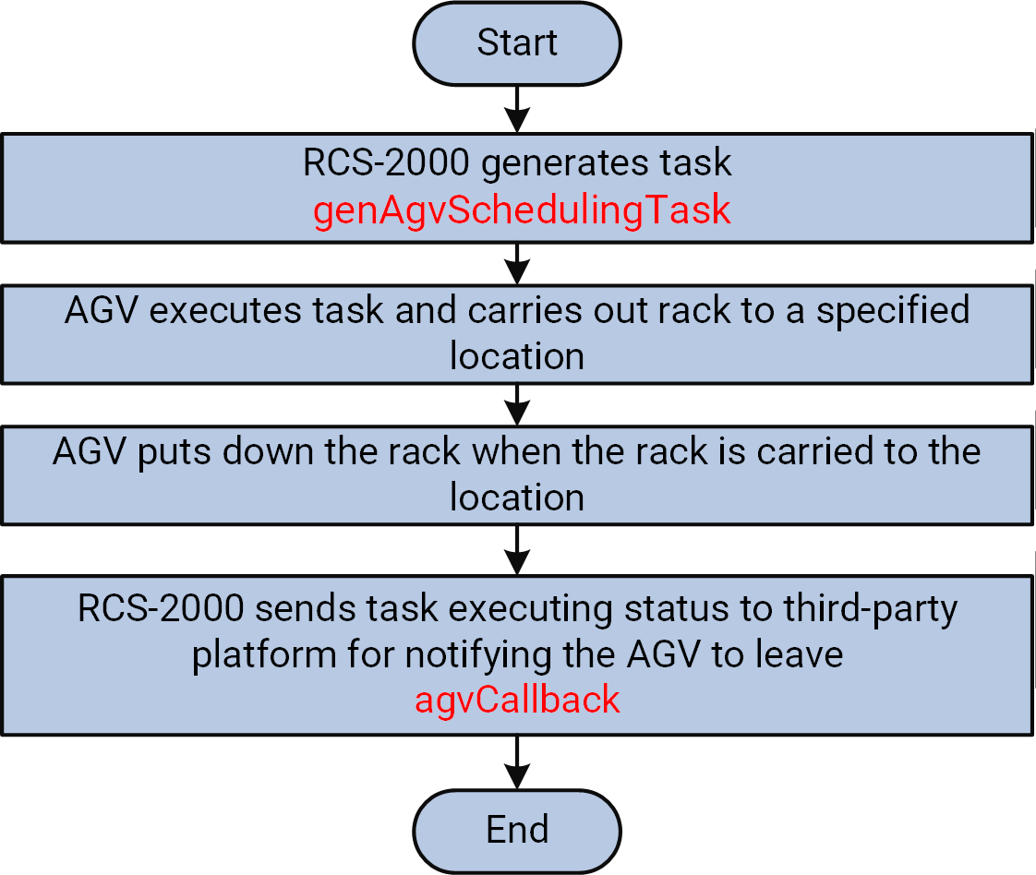

Figure 4-1 Flow of AMR Carrying Rack and Leaving without Rack
- The third-party platform calls genAgvSchedulingTask to generate task via the RCS-2000.
The AMR starts executing the task and carrying a rack to a specified location.
- The AMR puts down the rack when it arrived at the location.
- The RCS-2000 calls agvCallback to send task executing status to the third-party platform for notifying the AMR to leave.

AMR Carries Rack and Backs with Rack
In this application scene, the AMR carries a rack from the location A to a specific location

B after the third-party platform calling an API to set task parameters and generate task. When arriving at location B, the AMR keeps carrying the rack and waits until the third-party platform call an API to continue the task. And then the AMR carries back the rack whose goods has been processed to location A. This application scene is usually available when the time consumption of processing goods on rack is short.

Steps
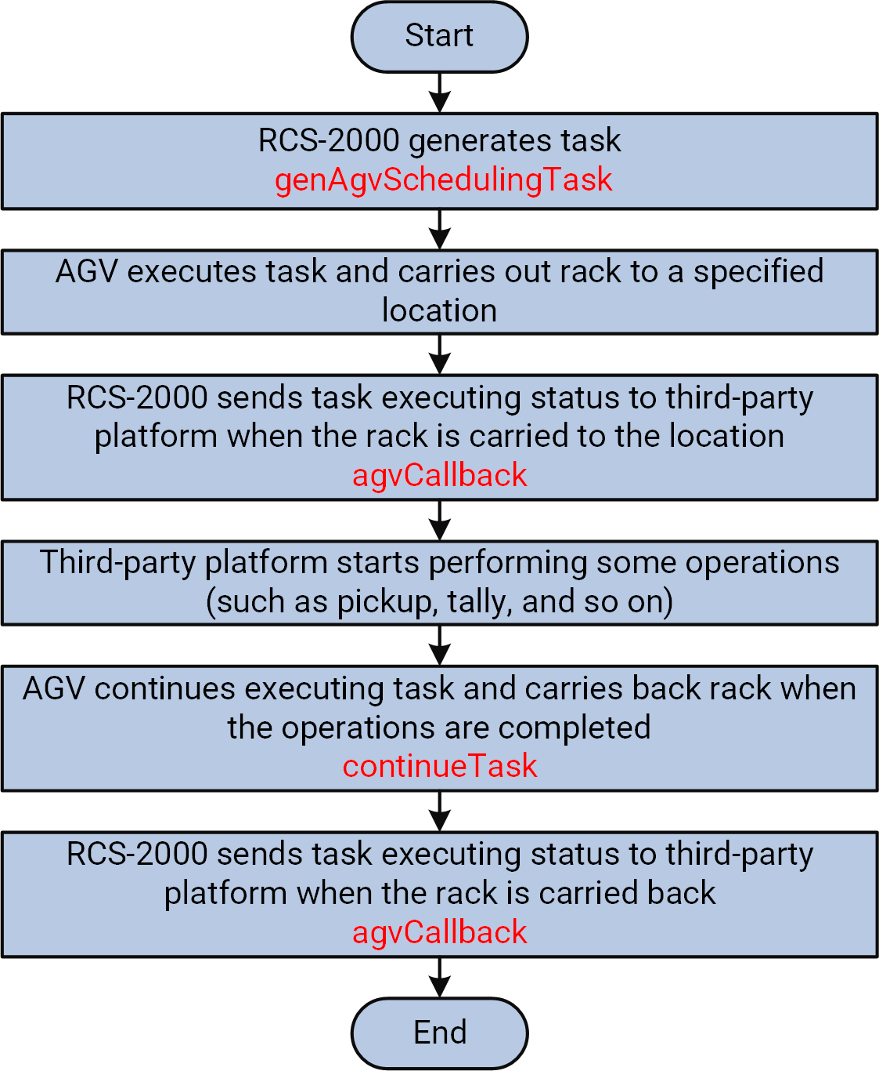

Figure 4-2 Flow of AMR Carrying Rack and Backing with Rack
- The third-party platform calls genAgvSchedulingTask to generate task via the RCS-2000.
The AMR starts executing the task and carrying out a rack to a specified location.
- The RCS-2000 calls agvCallback to send task executing status to the third-party platform when the rack is carried to the location.

- The third-party platform starts performing some operations, such as pickup, tally, and so on.
- The third-party platform calls continueTask when all operations are completed to continue executing task.
The AMR carries back the rack.
- The RCS-2000 calls agvCallback to send task executing status to the third-party platform when the rack is carried back.

Roller AMR Receives Materials
The roller AMR is mainly applied to improve the automatic level of factory logistics. It can reduce the length of conveyor belt during long distance transportation; for the workshop which cannot use FMR, it can convey very heavy material. Here introduces the progress of controlling roller AMR to complete the task of receiving materials.

Steps
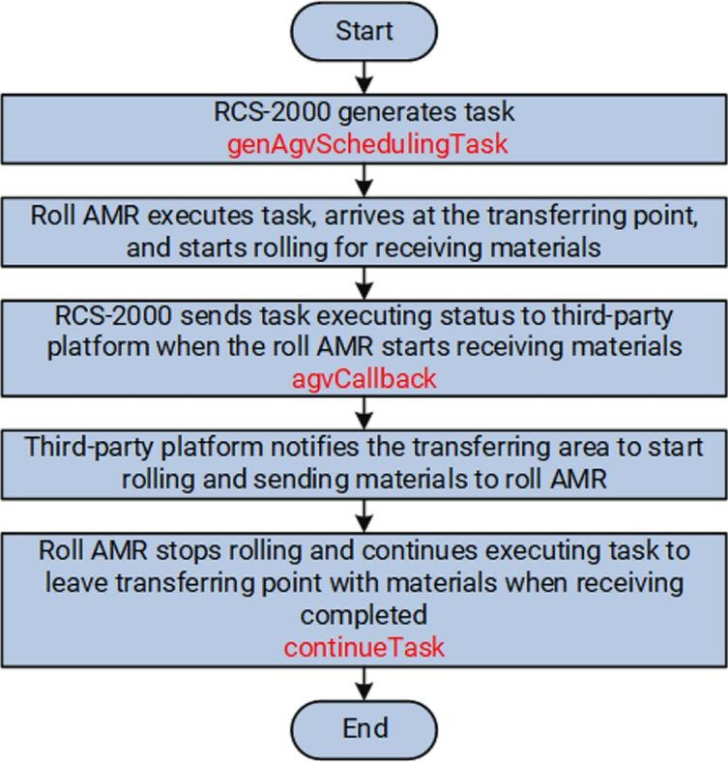

Figure 4-3 Flow of Roller AMR Receiving Materials
- The third-party platform calls genAgvSchedulingTask to generate task via the RCS-2000.
The roller AMR executes the task, arrives at the transferring point, and starts rolling to get ready for receiving materials.
- The RCS-2000 calls agvCallback to send the task executing status to the third-party platform when the AMR is ready for receiving materials.

- The third-party platform notifies the transferring area to start rolling and sending materials to the roller AMR.
- The third-party platform calls continueTask to continue executing task when the materials is received by roller AMR..
The roller AMR stops rolling and leaves the transferring point with received materials.

Pre-Schedule and Inbound via CTU at Conveyor Line
Ahead of container inbound to the conveyor line, the third-party platform applies the pre-schedule task and the AMR will be sent by the calling system and be ready for the containers. When the containers arrive at the conveyor line, the inbound task will be applied.

Steps
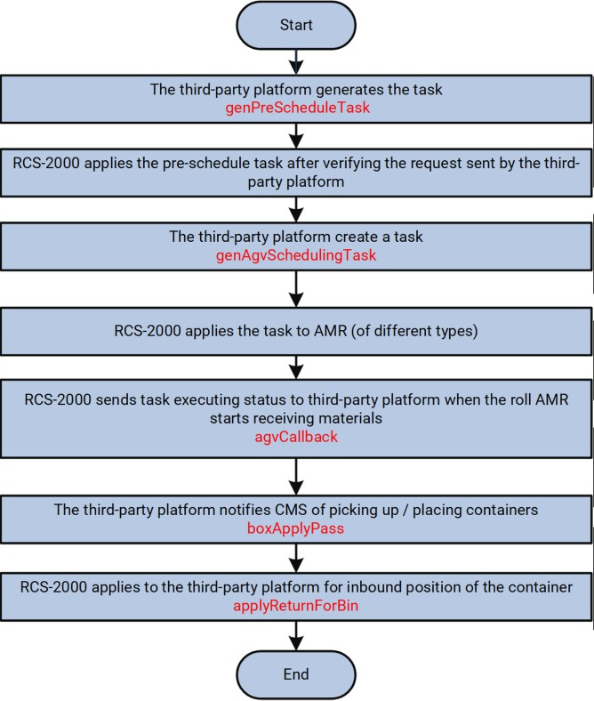

Figure 4-4 Flow of Pre-Schedule and Inbound via CTU at Conveyor Line
- The third-party platform calls genPreScheduleTask to generate the pre-schedule task and the RCS-2000 applies the pre-schedule task after verifying the request sent by the third-party platform.
- The third-party platform calls genAgvSchedulingTask to create a task and the RCS-2000 applies the task to AMR (of different types).


Note
The container destination is not obtained in this step. See in applyReturnForBin (CTU).

- The RCS-2000 calls agvCallback to send the task executing status (task starting, getting out of storage section, task canceling, task ending, etc.) to the third-party platform.
- The third-party platform calls boxApplyPass (CTU) to notify CMS of picking up / placing containers.
- The RCS-2000 calls applyReturnForBin (CTU) to apply to the third-party platform for inbound position of the container.

Inbound via CTU at Loader/Unloader
For each container arriving at the loader/unloader, the RCS-2000 needs to check with the third-party platform whether the inbound is allowed. Once it is allowed, the container enters the loader/unloader and waits for inbound. When there are a certain number of containers waiting at the loader/unloader, the RCS-2000 will batch apply to the third-party platform for inbound position of the containers and the CTU will execute the inbound task.

Steps
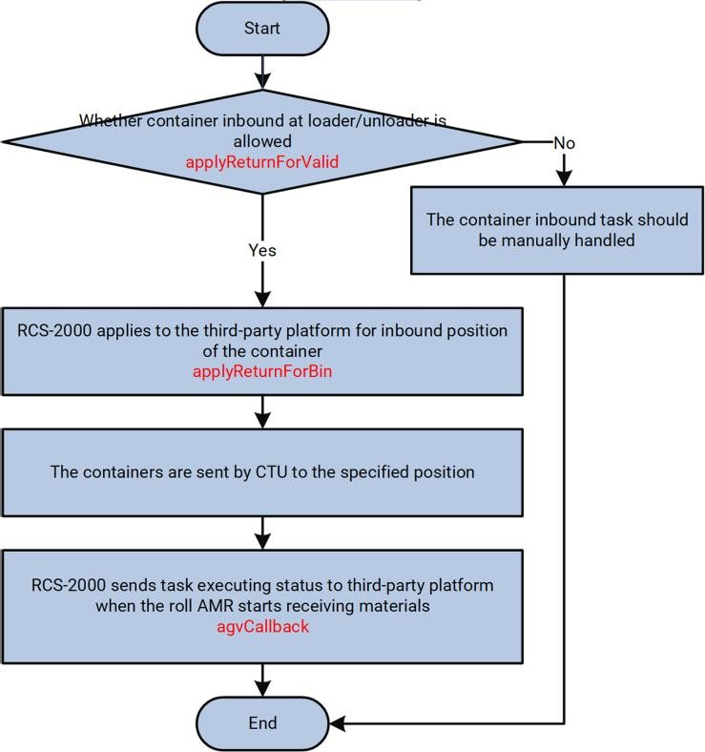

Figure 4-5 Flow of CTU Loader/Unloader Inbound
- The RCS-2000 calls applyReturnForValid (CTU) to check with the third-party platform whether the container inbound at the loader/unloader is allowed.

- If it is not allowed (usually due to the container problem), the containers will not enter the loader/unloader and should be instead manually handled; if yes, the RCS-2000 calls applyReturnForBin (CTU) to apply to the third-party platform for inbound position of the container.
- After the inbound position is obtained, the containers will be sent by CTU to the specified position.
- The RCS-2000 calls agvCallback to send the task executing status to the third-party platform.

Other CTU Application Scenarios
Other typical application scenarios are as follows:

Scenario | API
1. Container inbound/outbound at buffer rack picking station. | getOutPod (CTU / Buffer Rack Picking Station); returnPod (CTU / Buffer Rack Picking Station).
2. Batch/single outbound at conveyor line or loader/unloader. | genPreScheduleTask.
3. Outbound at conveyor line or loader/unloader by order. | genCtuGroupTaskBatch (CTU).
4. Inbound at conveyor line. | genPreScheduleTask; applyReturnForBin (CTU).
5. Inbound at loader/unloader. | applyReturnForValid (CTU); applyReturnForBin (CTU).
6. Apply for container picking-up/placing and get task execution notification. | agvCallback.
7. Notify CMS of picking up / placing containers. | boxApplyPass (CTU).

Chapter 5 API Reference

API List

List of Commonly Used APIs

Function | API Name | Provider
Create a task | genAgvSchedulingTask | RCS-2000
Continue executing the next sub task. | continueTask | RCS-2000
Cancel a task | cancelTask | RCS-2000
Send the task executing status to third-party platform | agvCallback | Third-party Platform

List of Optional APIs

Function | API Name | Provider
Set the task priority. | setTaskPriority | RCS-2000
Bind and unbind the rack and location. | bindPodAndBerth | RCS-2000
Bind and unbind the material batch and rack. | bindPodAndMat | RCS-2000
Enable or disable the location. | lockPosition | RCS-2000
Synchronize map information with that in RCS-2000. | syncMapDatas | RCS-2000
Search relations among rack, location, and material batch. | queryPodBerthAndMat | RCS-2000
Search for the task executing status. | queryTaskStatus | RCS-2000
Search for the AMR status. | queryAgvStatus | RCS-2000
Stop AMR(s). | stopRobot | RCS-2000
Resume a AMR. | resumeRobot | RCS-2000
Bind or unbind the container and bin. | bindCtnrAndBin | RCS-2000
Empty or unblock the specified area. | blockArea | RCS-2000
Send the pre-schedule. | genPreScheduleTask | RCS-2000
Clear all the data and notify RCS of updating. | clearRoadWay | RCS-2000
Container outbound, used for the buffer rack | getOutPod (CTU / Buffer | RCS-2000

Function | API Name | Provider
picking station. | Rack Picking Station)
Container inbound. | returnPod (CTU / Buffer Rack Picking Station) | RCS-2000
Apply and perform CTU outbound tasks in order. | genCtuGroupTaskBatch (CTU) | RCS-2000
Container picking-up/placing callback. | boxApplyPass (CTU) | RCS-2000
Check with the third-party platform whether the container inbound at the loader/unloader is allowed. | applyReturnForValid (CTU) | Third-party Platform
Apply to the third-party platform for inbound position of the container. | applyReturnForBin (CTU) | Third-party Platform
Send the alarm to the third-party platform. | warnCallback | Third-party Platform
Notify the third-party platform of the binding or unbinding operation. | bindNotify | Third-party Platform

API Provided by RCS-2000

genAgvSchedulingTask
The third-party platform creates a task and Robot Control System (RCS-2000) applies the task to AMR (of different types).

API Definition

Table 5-1 POST http://[address][:port]/rcms/services/rest/hikRpcService/genAgvSchedulingTask
API  Name | genAgvSchedulingTask
Function | The third-party platform creates a task and Robot Control System (RCS-2000) applies the task to AMR.
Protocol | REST
Provider | RCS-2000
Caller | Third-party platform
Request | Paramet er | Data Type | Max. Length | Req. or | Description

 |  |  |  | Opt.
 | reqCode | String | 32 | Req. | Request ID, if a request is repeatedly submitted, the request ID must be same.
 | reqTime | String | 20 | Opt. | Request timestamp, format: YYYY-MM-DD hh:mm:ss
 | clientCo de | String | 16 | Opt. | Third-party platform ID, e.g., PDA, HCWMS
 | tokenCo de | String | 64 | Opt. | Token ID, which is provided by RCS-2000 for third-party platform.
 | taskTyp | String | 16 | Req. | Task type, which is the same as the major task type configured in RCS-2000:  - Build-in task type:  "F01"-carry and transfer rack, "F02"-empty/full rack exchange, "F03"-carry and transfer by CMR, "F04"-rack outbound,  "F05"-rotate rack, "F06"-elevator task.  - FMR task type:  "F11"-transfer from high bay rack to workstation,  "F12"-transfer from workstation to high bay rack,  "F13"-transfer from roadway to workstation,  "F14"-transfer from workstation to roadway,  "F15"-shuttle from high bay rack to workstation,  "F16"-shuttle from workstation to high bay rack,  "F17"-shuttle from roadway to workstation,  "F18"-shuttle from workstation to roadway,  "F20"-cross-floor FMR main task.
 | ctnrTyp | String | 16 | Opt. | Container type. This field is dedicated for FMR tasks and CTU tasks, and it is required for FMR tasks.
 | ctnrCod | String | 32 | Opt. | Container ID. This field is dedicated for

 | e |  |  |  | FMR tasks and CTU tasks.
 | ctnrNu m | String | 2 | Opt. | Number of containers. This field is dedicated for FMR tasks, and it is used in the scenario of palletizing/depalletizing containers via FMR.
 | taskMo de | String | 1 | Opt. | Task mode: 0 (normal move), 1 (outbound move), 2 (inbound move), 3 (transfer move).  The outbound move cannot be interrupted, while the normal move and inbound move mode can. When an outbound move is completed, an inbound move or transfer move should be performed.
 | wbCode | String | 32 | Opt. | Workstation ID, which consists of letters and digits, and it must be same as that configured by RCS-2000.
 | position CodePat h | Objec t[] | 50 | Opt. | Rack moving pattern, which consists of multiple locations (up to 50 locations are allowed).
 | ⊢ type | String | / | Opt. | Location type:  "00"-actual location on map,  "01"-location of a specific material batch,  "02"-available location of area selection strategy,  "03"-rack No.,  "04"-available location in an area, "05"-bin ID (for FMR/CTU only), "06"-roadway ID,  "07"-container ID,  "08"-roadway strategy, "09"-roadway area, "10"-roadway bin,  "11"-conveyor (operating machine) No.,  "12"-CTU workstation (loader/unloader) No.,  "13"-position of roadway rack (used for rack outbound of the roadway).
 | ⊢  position | String | / | Opt. | Location ID, which is predefined with detailed coordinate information on map. It

 | Code |  |  |  | depends on the value of type.
 | podCod e | String | 16 | Opt. | Rack ID, it can be empty if no rack specified.
 | podDir | String | 4 | Opt. | Rack direction: "180"-leftward, "0"-rightward, "90"-upward, "-90"-downward; it can be empty if no direction specified.  If the destination is not the workstation, this field will be the direction of task destination.
 | podTyp | String | 16 | Opt. | Rack types:  "1"-empty rack of all types (default), "2"-type of rack linked with configured  workstation (if the linked rack is empty, it  also represents empty rack of all types),  other values-empty rack with a specific type.  Rack type No.: empty rack of the specified type.
 | material Lot | String | 32 | Opt. | Material lot ID.  You can set materialLot and podCode at same time to bind the rack with material lot, or you can set materialLot and wbCode to bind the material lot with the rack at the specified workstation.  If you are searching for racks by area/strategy, you can locate the rack with the bound material lot: 0-search for empty racks by area/strategy, 1-search for full racks by area/strategy, other values-search for racks by specified material lots.  For roadway tasks, this field is used for configuring the material trait value.
 | material Type | String | 32 | Opt. | Material type.  It is only required for CMR protocols.
 | priority | String | 3 | Opt. | Task priority, range: [1,127], and larger number corresponds to higher priority. If it is not configured, the task template priority takes effect.
 | agvCod | String | 5 | Opt. | AMR ID, if it is not configured, the RCS-

 | e |  |  |  | 2000 will automatically select an optimal AMR to execute the task.
 | taskCod e | String | 64 | Opt. | Task ID, if it is not configured, the system will generate automatically.
 | groupId | String | 16 | Opt. | Group ID, which is generally used for CTU outbound by groups. Tasks of a same group have higher priority for sharing AMR.  If the business requires outbound in order, you should call genCtuGroupTaskBatch (CTU) to perform outbound in order.  For LMR (latent mobile robot), the outbound order is according to the group ID: tasks of smaller group ID have higher priority for outbound.
 | agvTyp | String | 4 | Opt. | Device type.
 | position SelStrat egy | String | 2 | Opt. | The in and out rules for searching for racks by area / strategy / material lot: "1" (first-in-first-out by the time the rack arrives at the storage section), "2" (first-in-last-out by the time the rack arrives at the storage section), "9" (first-in-first-out by the time the rack is bound with the material lot), "10" (first-in-last-out by the time the rack is bound with the material lot).
 | data | String | 2000 | Opt. | Custom content in JSON format.
Respons e | code | String | 6 | Req. | Status code, see Status Code (Appendix A) for details.
 | messag e | String | 64 | Req. | Returned status description, e.g., "successful".
 | reqCode | String | 64 | Req. | Request ID, which is the same as that in corresponding request message
 | data | String | 2000 | Opt. | Custom content to be returned, such as task ID.
Remark s | One of wbCode and positionCodePath must be configured to confirm the location information in task. If you want to specify multiple locations in the task, e.g., start location and end location, the field positionCodePath should be configured.
Sample | Request | {  "reqCode": "468513",

 |  | } | "reqTime": "",  "clientCode": "",  "tokenCode": "",  "taskTyp": "F01",  "ctnrTyp": "",  "ctnrCode": "",  "ctnrNum": "",  "taskMode": "",  "wbCode": "", "positionCodePath": [{  "positionCode": "p01", "type": "00"  },  {  "positionCode": "x02", "type": "02"  }  ],  "podCode": "100001",  "podDir": "0",  "podTyp": "",  "materialLot": "",  "materialType": "",  "priority": "1",  "agvCode": "",  "taskCode": "",  "groupId": "",  "agvTyp": "", "positionSelStrategy ": "", "data": ""
 |  | {
 | Respon se |  | "code": “0”,  "data": "F01169C808C317111G",  "message": "successful",
 |  |  | "reqCode": "468513"

}

continueTask
Continue executing the next sub task.

API Definition

Table 5-2 POST http://[address][:port]/rcms/services/rest/hikRpcService/continueTask

API  Name | continueTask
Function | Continue executing the next sub task.
Protocol | REST
Provider | RCS-2000
Caller | Third-party platform
Request | Paramet er | Data Type | Max. Length | Req. or Opt. | Description
 | reqCode | String | 32 | Req. | Request ID, if a request is repeatedly submitted, the request ID must be same.
 | reqTime | String | 20 | Opt. | Request timestamp, format: YYYY-MM-DD hh:mm:ss
 | clientCo de | String | 16 | Opt. | Third-party platform ID, e.g., PDA, HCWMS
 | tokenCo de | String | 64 | Opt. | Token ID, which is provided by RCS-2000 for third-party platform.
 | wbCode | String | 32 | Opt. | Workstation ID. According to the input rack ID, the RCS-2000 will find the corresponding task and continue executing the next sub task.
 | podCod e | String | 16 | Opt. | Rack ID. According to the input rack ID, the RCS-2000 will find the corresponding task and continue executing the next sub task.
 | agvCod e | String | 5 | Opt. | AMR ID. According to the input AMR ID, the RCS-2000 will find the corresponding task and continue executing the next sub task.
 | taskCod e | String | 64 | Opt. | Task ID (UUID). According to the input task ID, the RCS-2000 will find the

 |  |  |  |  | corresponding task and continue executing the next sub task.
 | taskSeq | String | 32 | Opt. | Sub task No. to be specified to continue executing. If this field is not configured, by default, the next sub task will be executed.
 | nextPos itionCod e | Objec t | 40 | Opt. | The location information of sub tasks. This field is required when the task type is externally configured.  If this field is not configured, it indicates to perform the next sub task by default.
 | ⊢ position Code | String | / | Opt. | Location ID, which is predefined with detailed coordinate information on map. It depends on the value of type.
 | ⊢ type | String | / | Opt. | Location types: "00"-actual location on map, "02"-strategy
Respons e | code | String | 6 | Req. | Status code, see Status Code (Appendix A) for details.
 | messag e | String | 64 | Req. | Returned status description, e.g., "successful"
 | reqCode | String | 64 | Req. | Request ID, which is the same as that in corresponding request message
Remark s | Only one of wbCode, agvCode, taskCode, and podCode should be configured at one time, and the parameter to be configured depends on the trigger type configured in the task template. The parameter taskCode is recommended.
Sample Codes | Request | {  "reqCode": "123",  "reqTime": "",  "clientCode": "",  "tokenCode": "",  "wbCode": "",  "podCode": "",  "agvCode": "", "taskCode": "123456", "taskSeq": "", "nextPositionCode": {  "positionCode": "p02", "type": "00"  }  }
 | Respon | {

 | se | "code": "0",  "message": "successful", "reqCode": "123"  }

cancelTask
Cancel the task that is executing or is generated but waiting for being executed.

API Definition

Table 5-3 POST http://[address][:port]/rcms/services/rest/hikRpcService/cancelTask

API  Name | cancelTask
Function | Cancel the task that is executing or is generated but waiting for being executed.
Protocol | REST
Provider | RCS-2000
Caller | Third-party platform
Request | Paramet er | Data Type | Max. Length | Req. or Opt. | Description
 | reqCode | String | 32 | Req. | Request ID, if a request is repeatedly submitted, the request ID must be same.
 | reqTime | String | 20 | Opt. | Request timestamp, format: YYYY-MM-DD hh:mm:ss
 | clientCo de | String | 16 | Opt. | Third-party platform ID, e.g., PDA, HCWMS
 | tokenCo de | String | 64 | Opt. | Token ID, which is provided by RCS-2000 for third-party platform.
 | forceCa ncel | String | 16 | Opt. | Task cancel mode:  "0" (default)-AMR puts down the rack at current location and its status turns to "idle",  "1"-AMR carries the rack and returns back, this mode is supported by LMR (latent mobile robot) and CTU only.
 | matterA rea | String | 16 | Opt. | Inbound area No., it is valid only when the value of forceCancel is "1"; if this field is

 |  |  |  |  | not configured, the inbound area is the storage area.
 | agvCod e | String | 5 | Opt. | AMR ID, whose executing task will be canceled.
 | taskCod e | String | 64 | Opt. | ID (UUID) of task to be canceled.
Respons e | code | String | 6 | Req. | Status code, see Status Code (Appendix A) for details.
 | messag e | String | 64 | Req. | Returned status description, e.g., "successful".
 | reqCode | String | 64 | Req. | Request ID, which is the same as that in corresponding request message
Remark s | One of taskCode and agvCode must be configured to confirm the task to be canceled or the AMR to be freed. If both the two parameters are configured, only the value of agvCode will take effect.
Sample Codes | Request | {  "reqCode": "1541954B96B1112",  "reqTime": "",  "clientCode": "",  "tokenCode": "",  "forceCancel": "1",  "matterArea": "abc",  "agvCode": "", "taskCode": "123456"  }
 | Respon se | {  "code": “0”,  "message": "successful", "reqCode": "1541954B96B1112"  }

Remarks
      - For canceling tasks by task ID, if an AMR is executing a task and carrying a rack, when the cancel mode is "0", the AMR will put down the rack at any location, and its status turns to "idle"; when the cancel mode is "1", the AMR will carry the rack and execute inbound, if there is no space of inbound area, the error will be returned and canceling failed. For canceling tasks by task ID, if a CTU is executing a task and loading a container, when the cancel mode is "0", the container will remain on the CTU and should be carried away manually; when the cancel mode is "1", the CTU will carry the container to the specified bin or empty bin.
      - FMR only supports the cancel mode "0".

setTaskPriority
Set the task priority from 1 to 127, and the larger the value, the higher the priority. The priority takes effect only when the number of AMRs is less than that of tasks and there are multiple tasks with different priorities. The tasks will be assigned to the AMR according to priority order. The task priority may influence the route scheduling, when there is route conflict, the AMR with high-priority task uses the route.

API Definition

Table 5-4 POST http://[address][:port]/rcms/services/rest/hikRpcService/setTaskPriority

API  Name | setTaskPriority
Function | Set task priority from 1 to 127, and the larger the value, the higher the priority.
Protocol | REST
Provider | RCS-2000
Caller | Third-party platform
Request | Paramet er | Data Type | Max. Length | Req. or Opt. | Description
 | reqCode | String | 32 | Req. | Request ID, if a request is repeatedly submitted, the request ID must be same.
 | reqTime | String | 20 | Opt. | Request timestamp, format: YYYY-MM-DD hh:mm:ss
 | clientCo de | String | 16 | Opt. | Third-party platform ID, e.g., PDA, HCWMS
 | tokenCo de | String | 64 | Opt. | Token ID, which is provided by RCS-2000 for third-party platform.
 | prioritie s | Objec t[] | / | Req. | Task list.
 | ⊢ taskCod e | String | 64 | Req. | Task ID (UUID)
 | ⊢  priority | String | 32 | Req. | Task priority, range: [1,127], the larger the value, the higher the priority.
Respons e | code | String | 6 | Req. | Status code, see Status Code (Appendix A) for details.
 | messag e | String | 64 | Req. | Returned status description, e.g., "successful"

 | reqCode | String | 64 | Req. | Request ID, which is the same as that in corresponding request message
Remark s | You can set the priority for the tasks that are not assigned to the AMR only; If the task has been assigned to AMR, it is invalid for setting task priority.
Sample Codes | Request | {  "reqCode": "1234567", "reqTime": "",  "clientCode": "",  "tokenCode": "",  "priorities": [{  "priority": "1",  "taskCode": "1232"  },  {  "priority": "2",  "taskCode": "3214"  }  ]  }
 | Respon se | {  "code": “0”,  "message": "successful", "reqCode": "1234567"  }

bindPodAndBerth
Bind or unbind the rack and location. When the binding is completed, the location can be searched by rack ID, which is recorded on the position. After unbinding the rack from the location, the rack ID will be cleared from the position.

API Definition

Table 5-5 POST http://[address][:port]/rcms/services/rest/hikRpcService/bindPodAndBerth
API  Name | bindPodAndBerth
Function | Bind or unbind a rack and one location.
Protocol | REST
Provider | RCS-2000
Caller | Third-party platform

Remark s | When unbinding, to avoid incorrect operation, both parameters podCode and positionCode should be configured for verification.
Request | Paramet er | Data Type | Max. Length | Req. or Opt. | Description
 | reqCode | String | 32 | Req. | Request ID, if a request is repeatedly submitted, the request ID must be same.
 | reqTime | String | 20 | Opt. | Request timestamp, format: YYYY-MM-DD hh:mm:ss
 | clientCo de | String | 16 | Opt. | Third-party platform ID, e.g., PDA, HCWMS
 | tokenCo de | String | 64 | Opt. | Token ID, which is provided by RCS-2000 for third-party platform.
 | podCod e | String | 16 | Req. | Rack ID
 | position Code | String | 32 | Req. | Position ID, which is predefined with detailed coordinate information on map, and it is a unique string configured via RCS-2000.
 | podDir | String | 6 | Opt. | Rack direction: "0"-horizontal (default), "1"-vertical. If this field is not configured, the rack direction is horizontal by default.  The position configuration is in priority. If the position direction is configured as horizontal and vertical, this field is invalid; if the position direction is configured as all-direction, this field takes effect.
 | charact erValue | String | 64 | Opt. | Trait value (only for racks on the roadway). It can be the material type or batch information.
 | indBind | String | 1 | Req. | Bind or unbind: "1"-bind, "0"-unbind.
Respons e | code | String | 6 | Req. | Status code, see Status Code (Appendix A) for details.
 | messag e | String | 64 | Req. | Returned status description, e.g., "successful".
 | reqCode | String | 64 | Req. | Request ID, which is the same as that in corresponding request message
Sample | Request | {

Codes |  | "reqCode": "12345678",  "reqTime": "",  "clientCode": "",  "tokenCode": "",  "podCode": "100001", "positionCode": "p05", "podDir": "0",  "characterValue": "0",  "indBind": "1"  }
 | Respon se | {  "code": “0”,  "message": "successful", "reqCode": "12345678"  }

bindCtnrAndBin
Bind or unbind the container and bin. For CTU (carton transfer unit) and FMR tasks, you can call this API to write in the container type and ID to the bin.

Request URL Definition

Table 5-6 POST http://[address][:port]/rcms/services/rest/hikRpcService/bindCtnrAndBin

API  Name | bindCtnrAndBin
Function | Bind or unbind the container and bin.
Protocol | REST
Provider | RCS-2000
Caller | Third-party platform
Request | Paramet er | Data Type | Max. Length | Req. or Opt. | Description
 | reqCode | String | 32 | Req. | Request ID, if a request is repeatedly submitted, the request ID must be same.
 | reqTime | String | 20 | Opt. | Request timestamp, format: YYYY-MM-DD hh:mm:ss
 | clientCo de | String | 16 | Opt. | Third-party platform ID, e.g., PDA, HCWMS

 | tokenCo de | String | 64 | Opt. | Token ID, which is provided by RCS-2000 for third-party platform.
 | ctnrCod e | String | 30 | Req. | Container ID
 | ctnrTyp | String | 16 | Req. | Container type
 | stgBinC ode | String | 32 | Opt. |   Bin ID.  Note  One of stgBinCode and positionCode is required.
 | binNam e | String | 32 | Opt. | Custom bin ID, which will be verified by the RCS-2000.  For example, when the system configuration number 10110 is set to true, it indicates that the custom bin ID and bin ID should be one-to-one, if one custom bin ID corresponds to multiple bin ID, an error will be reported.
 | charact erValue | String | 64 | Opt. | Trait value (only for the FMR roadway)
 | position Code | String | 32 | Req. | Position ID, which is predefined with detailed coordinate information on the map, and it is a unique string configured via RCS-2000.  This field is used for binding or unbinding containers and the bin of virtual racks.    Note  One of stgBinCode and positionCode is required.
 | indBind | String | 1 | Req. | Bind or unbind: "1"-bind, "0"-unbind.
Respons e | code | String | 6 | Req. | Status code, see Status Code (Appendix A) for details.
 | data | String | 2000 | Opt. | Custom content to be returned.
 | messag | String | 64 | Req. | Returned status description, e.g.,

 | e |  |  |  | "successful".
 | reqCode | String | 64 | Req. | Request ID, which is the same as that in corresponding request message
Sample Codes | Request | {  "reqCode": "12345678",  "reqTime":"",  "clientCode": "",  "tokenCode":"",  "ctnrCode": "",  "ctnrTyp": "C1",  "stgBinCode": "p05", "positionCode": "p05", "indBind": "1"  }
 | Respon se | {  "code": “0”,  "data": "",  "message": "successful", "reqCode": "12345678"  }

genPreScheduleTask
Robot Control System (RCS) applies the pre-schedule task after verifying the request sent by the third-party platform. The pre-schedule task is to notify RCS of the actual task in advance so that RCS can send a free AMR to the target position and the AMR is in standby for the upcoming actual task. It improves the scheduling efficiency.

API Definition

Table 5-7 POST http://[address][:port]/rcms/services/rest/hikRpcService/genPreScheduleTask
API  Name | genPreScheduleTask
Function | Robot Control System (RCS) applies the pre-schedule task after verifying the request sent by the third-party platform.
Protocol | REST
Provider | RCS-2000
Caller | Third-party platform
Request | Paramet er | Data Type | Max. Length | Req. or | Description

 |  |  |  | Opt.
 | reqCode | String | 32 | Req. | Request ID, if a request is repeatedly submitted, the request ID must be same.
 | reqTime | String | 20 | Opt. | Request timestamp, format: YYYY-MM-DD hh:mm:ss
 | clientCo de | String | 16 | Opt. | Third-party platform ID, e.g., PDA, HCWMS
 | tokenCo de | String | 64 | Opt. | Token ID, which is provided by RCS-2000 for third-party platform.
 | position Code | String | 32 | Req. | Task position.
 | nextTas k | String | 32 | Req. | Pre-schedule task time period. Remaining seconds before the actual task is generated: "-1" (clear the pre-schedule tasks of a position).
 | agvTyp | String | 256 | Req. | AMR type, with which the complete the actual task.
 | waitTim e | String | 32 | Opt. | Waiting time.
 | priority | String | 3 | Opt. | Task priority, range: [1,127], and larger number corresponds to higher priority. If it is not configured, the task template priority takes effect.
 | useable Layers | String | / | Opt. | Number of available empty bins (for the CTU only) on an AMR. When docking with the conveyor line, the CTU with one empty bin can be dispatched; when docking with the loader/unloader, only the empty CTU with the same number of bins can be dispatched.
 | cacheC ount | String | / | Opt. | Number of cache containers (for the loader/unloader and conveyor line).  The number of pre-schedule tasks can be calculated via the value of useableLayers and cacheCount. And the calculation result has higher priority than preTaskQty.
 | update | Num ber |  | Opt. | Whether to update the pre-schedule tasks: 0 (each time add a new pre-schedule task

to the total number of tasks)
1 (refresh and calculate the total number of pre-schedule tasks by cacheCount and useableLayers).
 | preTask Qty | Num ber | / | Opt. | Number of pre-schedule tasks. When the value of update is 1, the number of pre-schedule tasks will be updated to the value of this filed.
Respons e | code | String | 6 | Req. | Status code, see Status Code (Appendix A) for details.
 | messag e | String | 64 | Req. | Returned status description, e.g., "successful".
 | reqCode | String | 64 | Req. | Request ID, which is the same as that in corresponding request message
Sample | Request | For container inbound at conveyor line via CTU (apply a pre-schedule task every time a container is scanned):  {  "reqCode": "123",  "positionCode":"pos1", //The pre-schedule task position/bin. "nextTask": "300", //The actual task is expected to be applied  within 5 minutes. If not, the pre-schedule AMR will be free. "agvTyp": "1",  "priority": "",  "useableLayers": "1", //Each pre-schedule corresponds to a container and requires a CTU bin.  "cacheCount": "1", //Each pre-schedule corresponds to a container  "update": "0" //Each time add a new pre-schedule task to the total number of tasks.  }
For container inbound at conveyor line via CTU (update the total number of pre-schedule tasks every time a container is scanned):
{
"reqCode": "123",
"positionCode": "pos1", //The pre-schedule task position/bin. "nextTask": "300", //The actual task is expected to be applied
within 5 minutes. If not, the pre-schedule AMR will be free. "agvTyp": "1",
"priority": "",
"useableLayers": "1", //Each pre-schedule corresponds to a container and requires a CTU bin.
"cacheCount": "4", //4 containers currently at the conveyor

line, which requires 4 pre-schedule tasks.
"update": "1", //Refresh and calculate the total number of pre-schedule tasks (cacheCount/useableLayers).
}
For container inbound at loader/unloader:
{
"reqCode": "123",
"positionCode": "pos1", //The pre-schedule task position/bin. "nextTask": "300", //The actual task is expected to be applied
within 5 minutes. If not, the pre-schedule AMR will be free. "agvTyp": "1",
"priority": "",
"useableLayers": "6", //Number of available empty bins (for the CTU only) docking with loader/unloader.
"cacheCount": "12", //12 cached containers requiring loader/unloader inbound.
"update": "1", //Refresh and calculate the total number of pre-schedule tasks (cacheCount/useableLayers).
}
 | Respon se | {  "code": "0",  "message": "successful", "reqCode": "123"  }

clearRoadWay
Clear all the data of roadways, containers, or racks and notify RCS of updating the information. Transport roadway: cannot be cleared when the outbound lock capacity is not 0; when the outbound capacity is set to 0, the inbound capacity will be recalculated. FMR roadway: cannot be cleared when the outbound and inbound lock capacity is not 0; when the configuration is completed, the capacity will be recalculated.

API Definition

Table 5-8 POST http://[address][:port]/rcms/services/rest/hikRpcService/clearRoadWay

API  Name | clearRoadWay
Function | Clear all the roadway data and notify RCS of updating roadway information.
Protocol | REST
Provider | RCS-2000
Caller | Third-party platform

Request | Paramet er | Data Type | Max. Length | Req. or Opt. | Description
 | reqCode | string | 32 | Req. | Request ID. If a request is submitted repeatedly, the request ID must be the same.
 | reqTime | string | 20 | Opt. | Request timestamp, format: YYYY-MM-DD hh:mm:ss
 | clientCo de | string | 16 | Opt. | Third-party platform ID, e.g., PDA, HCWMS.
 | tokenCo de | string | 64 | Opt. | Token ID, which is provided by RCS-2000.
 | roadWa yCode | string | 16 | Req. | Roadway ID.
Respons e | code | string | 6 | Req. | Status code, see Status Code (Appendix A) for details.
 | messag e | string | 64 | Req. | Returned status description.
 | reqCode | string | 64 | Req. | Request ID.
Sample Request | Sample | {  "reqCode": "123",  "reqTime":"",  "clientCode": "",  "tokenCode":"",  "roadWayCode": "",  }
 | Request | {  "code": “0”,  "message": "successful", "reqCode": "123"  }

lockPosition
Enable or disable the position. When the location is disabled, it cannot be found in the

area.

API Definition

Table 5-9 POST http://[address][:port]/rcms/services/rest/hikRpcService/lockPosition

API  Name | lockPosition
Function | Enable or disable the position. When the location is disabled, it cannot be found in the area.
Protocol | REST
Provider | RCS-2000
Caller | Third-party platform
Request | Paramet er | Data Type | Max. Length | Req. or Opt. | Description
 | reqCode | String | 32 | Req. | Request ID, if a request is repeatedly submitted, the request ID must be same.
 | reqTime | String | 20 | Opt. | Request timestamp, format: YYYY-MM-DD hh:mm:ss
 | clientCo de | String | 16 | Opt. | Third-party platform ID, e.g., PDA, HCWMS
 | tokenCo de | String | 64 | Opt. | Token ID, which is provided by RCS-2000 for third-party platform.
 | position Code | String | 32 | Req. | Position ID, which is predefined with detailed coordinate information on map, and it is a unique string configured via RCS-2000.
 | indBind | String | 1 | Req. | Enable or disable: "1"-enable, "0"-disable.
Respons e | code | String | 6 | Req. | Status code, see Status Code (Appendix A) for details.
 | messag e | String | 64 | Req. | Returned status description, e.g., "successful".
 | reqCode | String | 64 | Req. | Request ID, which is the same as that in corresponding request message
 | data | String | 2000 | Opt. | Custom content to be returned, such as task ID.
Sample | Request | {  "reqCode": "1541954B96B1112",

Codes |  | "reqTime": "",  "clientCode": "",  "tokenCode": "", "positionCode": "p02", "indBind": "1"  }
 | Respon se | {  "code": “0”,  "message": "successful", "reqCode": "1541954B96B1112"  }

stopRobot
Stop the specified AMR or all AMRs.

API Definition

Table 5-10 POST http://[address][:port]/rcms/services/rest/hikRpcService/stopRobot

API  Name | stopRobot
Function | Stop the specified AMR or all AMRs.
Protocol | REST
Provider | RCS-2000
Caller | Third-party platform
Request | Paramet er | Data Type | Max. Length | Req. or Opt. | Description
 | reqCode | String | 32 | Req. | Request ID, if a request is repeatedly submitted, the request ID must be same.
 | reqTime | String | 20 | Opt. | Request timestamp, format: YYYY-MM-DD hh:mm:ss
 | clientCo de | String | 16 | Opt. | Third-party platform ID, e.g., PDA, HCWMS
 | tokenCo de | String | 64 | Opt. | Token ID, which is provided by RCS-2000 for third-party platform.
 | robotCo unt | String | 64 | Opt. | The number of AMRs to be stopped: "-1" (all AMRs).

Note
- One of robotCount and robots is required.
- To stop all AMRs, set robotCount to "-1", while to stop parts of AMRs, input the corresponding AMR ID list in robots.
 | mapSho rtName | String | 32 | Opt. | Alias of the map where the AMR locates.  Note  This field is required when the value of robotCount is "-1".
 | robots | String [] | 16 | Opt. | List of AMR IDs.  Note  - One of robotCount and robots is required.  - To stop all AMRs, set robotCount to "-1", while to stop parts of AMRs, input the corresponding AMR ID list in robots.
Respons e | code | String | 6 | Req. | Status code, see Status Code (Appendix A) for details.
 | messag e | String | 64 | Req. | Returned status description, e.g., "successful".
 | reqCode | String | 64 | Req. | Request ID, which is the same as that in corresponding request message
Sample Codes | Request | {  "reqCode": "1541954B96B1112",  "reqTime": "",  "clientCode": "",  "tokenCode": "",  "robotCount": "2",  "mapShortName": "", "robots": [  "1001",  "1002"  ]  }
 | Respon | {

 | se | "code": “0”,  "message": "successful", "reqCode": "1541954B96B1112"  }

syncMapDatas
Synchronize map information with that in RCS-2000.

API Definition

Table 5-11 POST http://[address][:port]/rcms/services/rest/hikRpcService/syncMapDatas
API  Name | syncMapDatas
Function | Synchronize map information with that in RCS-2000.
Protocol | REST
Provider | RCS-2000
Caller | Third-party platform
Request | Paramet er | Data Type | Max. Length | Req. or Opt. | Description
 | reqCode | String | 32 | Req. | Request ID, if a request is repeatedly submitted, the request ID must be same.
 | reqTime | String | 20 | Opt. | Request timestamp, format: YYYY-MM-DD hh:mm:ss
 | clientCo de | String | 16 | Opt. | Third-party platform ID, e.g., PDA, HCWMS
 | tokenCo de | String | 64 | Opt. | Token ID, which is provided by RCS-2000 for third-party platform.
 | mapDat aCode | String | 32 | Opt. | Unique location code on map
 | mapSho rtName | String | 32 | Req. | Alias of the map that needs to be synchronized
 | dataTyp | String | 6 | Opt. | Map element type, when this field is not configured, all location codes of the map will be synchronized.
Respons | code | String | 6 | Req. | Status code, see Status Code (Appendix A)

e |  |  |  |  | for details.
 | messag e | String | 64 | Req. | Returned status description, e.g., "successful".
 | reqCode | String | 64 | Req. | Request ID, which is the same as that in corresponding request message
 | data | List
 | cooX | String | 8 | Req. | X-coordinate of location code, unit: mm
 | cooY | String | 8 | Req. | Y-coordinate of location code, unit: mm
 | dataTyp | String | 2 | Req. | Map element types: "1"-storage section, "10"-workstation, "11"-charge station, "20"-interim storage area, "55"-roadway storage area
 | directio n | String | 8 | Opt. | Working station direction, in which a staff faces a rack to pickup: "180"-leftward, "0"-rightward, "90"-upward,"-90"-downward.
 | mapCod e | String | 16 | Req. | Map ID
 | mapDat aCode | String | 32 | Req. | Unique location code on map
 | position Code | String | 32 | Req. | Position ID, which is predefined with detailed coordinate information on map, and it is a unique string configured via RCS-2000.
 | berthTy pe | String | 2 | Opt. | Storage section types:  "1"-outer storage section, "2"-inner storage section, "3"-normal storage section.    Note  This field is required when the value of dataTyp is 1.
Sample Codes | Request | {  "reqCode": "1541954B96B1112",  "reqTime": "",  "clientCode": "",  "tokenCode": "",  "mapDataCode": "xxxxxx",

"mapShortName": "xxxxxx", "dataTyp": ""
}
 | Respon se | {  "code": "0",  "message": "successful", "reqCode": "1541954B96B1112",  "data": [{  "berthType": "3",  "cooX": "17000.0",  "cooY": "18000.0",  "dataTyp": "1",  "direction": "0",  "mapCode": "AA",  "mapDataCode": "011724AA012414",  "positionCode": "011724AA012414"  },  {  "berthType": "3",  "cooX": "11000.0",  "cooY": "21999.0",  "dataTyp": "10",  "direction": "0",  "mapCode": "AA",  "mapDataCode": "007586AA015172",  "positionCode": "104"  }  ]  }

blockArea
Empty or unblock the specified area. Emptying an area is to remove all AMRs from the area and block the area. When the area is blocked, all AMRs in the area will stop and AMRs outside the area are not allowed to enter.

API Definition

Table 5-12 POST http://[address][:port]/rcms/services/rest/hikRpcService/blockArea

API  Name | blockArea
Function | Empty or unblock the specified area. Emptying an area is to remove all objects from the area and block the area.

Protocol | REST
Provider | RCS-2000
Caller | Third-party platform
Remark s | - You can configure the area via RCS-2000  - When the area is emptied, the AMRs in the area leaves, and the AMRs to  enter the area will bypass.
Request | Paramet er | Data Type | Max. Length | Req. or Opt. | Description
 | reqCode | String | 32 | Req. | Request ID, if a request is repeatedly submitted, the request ID must be same.
 | reqTime | String | 20 | Opt. | Request timestamp, format: YYYY-MM-DD hh:mm:ss
 | clientCo de | String | 16 | Opt. | Third-party platform ID, e.g., PDA, HCWMS
 | tokenCo de | String | 64 | Opt. | Token ID, which is provided by RCS-2000 for third-party platform.
 | matterA rea | String | 16 | Req. | ID of the area to be emptied or unblocked
 | indBind | String | 1 | Req. | Empty or unblock the area: "1"-empty, "0"-unblock.
 | pause | String | 1 | Req. | Whether to pause emptying the area: "0" (no, default value) , 1 (yes).  When the area is already emptied, whether to stop all AMRs on the map: "0" (no, default value) , 1 (yes).
 | control Mod | String | 2 | Req. | Scheduling mode: "0" (move out of the area, default value), "1" (move to the interim park area), "2" (move to the specified area), "-1" (blocking mode, when an area is blocked, AMRs in this area will stop and no other AMR is allowed to enter this area).
 | targetAr ea | String | 16 | Opt. | The specified area ID. This field is required when the value of controlMod is "2".
 | noticeT hird | String | 2 | Req. | Whether to notify the third-party platform when the area is emptied: 0 (no), 1 (yes).

Respons e | code | String | 6 | Req. | Status code, see Status Code (Appendix A) for details.
 | messag e | String | 64 | Req. | Returned status description, e.g., "successful".
 | reqCode | String | 64 | Req. | Request ID, which is the same as that in corresponding request message
Sample Codes | Request | {  "reqCode": "1541954B96B1112",  "reqTime": "",  "clientCode": "",  "tokenCode": "",  "matterArea": "2",  "indBind": "1",  "pause": "0", "controlMod": "2"， "targetArea":"HF002"  }
 | Respon se | {  "code": "0",  "message": "successful", "reqCode": "1541954B96B1112"  }

resumeRobot
Resume the AMR, the resumed AMR will continue executing the uncompleted task.

API Definition

Table 5-13 POST http://[address][:port]/rcms/services/rest/hikRpcService/resumeRobot

API  Name | resumeRobot
Function | Resume the AMR, the resumed AMR will continue executing the uncompleted task.
Protocol | REST
Provider | RCS-2000
Caller | Third-party platform
Request | Paramet er | Data Type | Max. Length | Req. or Opt. | Description

 | reqCode | String | 32 | Req. | Request ID, if a request is repeatedly submitted, the request ID must be same.
 | reqTime | String | 20 | Opt. | Request timestamp, format: YYYY-MM-DD hh:mm:ss
 | clientCo de | String | 16 | Opt. | Third-party platform ID, e.g., PDA, HCWMS
 | tokenCo de | String | 64 | Opt. | Token ID, which is provided by RCS-2000 for third-party platform.
 | robotCo unt | String | 64 | Opt. | The number of AMRs to be resumed: "-1" (all AMRs).    Note  - One of robotCount and robots is required.  - To resume all AMRs, set robotCount to "-1", while to resume parts of AMRs, input the corresponding AMR ID list in robots.
 | mapSho rtName | String | 32 | Opt. | Alias of the map where the AMR locates.  Note  This field is required when the value of robotCount is "-1".
 | robots | String [] | 16 | Opt. | List of AMR IDs.  Note  - One of robotCount and robots is required.  - To resume all AMRs, set robotCount to "-1", while to resume parts of AMRs, input corresponding AMR list via field robots.
Respons e | code | String | 6 | Req. | Status code, see Status Code (Appendix A) for details.
 | messag e | String | 64 | Req. | Returned status description, e.g., "successful".
 | reqCode | String | 64 | Req. | Request ID, which is the same as that in corresponding request message

Sample Codes | Request | {  "reqCode": "1541954B96B1112",  "reqTime": "",  "clientCode": "",  "tokenCode": "",  "robotCount": "2",  "mapShortName": "", "robots": [  "1001",  "1002"  ]  }
 | Respon se | {  "code": "0",  "message": "successful", "reqCode": "1541954B96B1112"  }

queryAgvStatus
Search for AMR status, including the AMR battery.

API Definition

Table 5-14 POST http://[address]:8182/rcms-dps/rest/queryAgvStatus

API  Name | queryAgvStatus
Function | Search for AMR status, including the AMR battery.
Protocol | REST
Provider | RCS-2000
Caller | Third-party platform
Remark s | - API calling frequency:  number of AMRs is less than 100: 5 seconds;  number of AMRs is between 100 and 200: 10 seconds; number of AMRs is between 200 and 300: 15 seconds.  - The request URI is "http://[address]:8182/rcms-dps/rest/queryAgvStatus"
Request | Paramet er | Data Type | Max. Length | Req. or Opt. | Description
 | reqCode | String | 32 | Req. | Request ID, if a request is repeatedly submitted, the request ID must be same.

 | reqTime | String | 20 | Opt. | Request timestamp, format: YYYY-MM-DD hh:mm:ss
 | clientCo de | String | 16 | Opt. | Third-party platform ID, e.g., PDA, HCWMS
 | tokenCo de | String | 64 | Opt. | Token ID, which is provided by RCS-2000 for third-party platform.
 | mapSho rtName | String | 32 | Opt. | Alias of the map where the AMR locates.
Respons e | code | String | 6 | Req. | Status code, see Status Code (Appendix A) for details.
 | data | Object
 | robotCo de | String | 5 | Req. | AMR ID
 | robotDir | String | 4 | Req. | AMR direction, range: [-180,360] degrees
 | robotIp | String | 64 | Opt. | AMR IP address
 | battery | String | 4 | Req. | AMR battery, range: [0,100]
 | posX | String | 8 | Req. | AMR X-coordinate, unit: millimeter
 | posY | String | 8 | Req. | AMR Y-coordinate, unit: millimeter
 | mapCod e | String | 32 | Req. | ID of map where the AMR locates
 | speed | String | 6 | Req. | AMR current speed, unit: mm/s
 | status | String | 6 | Req. | AMR status, see AMR Status for details.
 | exclTyp e | String | 1 | Req. | Whether the AMR is excluded: "1"-excluded, "0"-not excluded.    Note  No task will be assigned to the excluded AMR.
 | stop | String | 1 | Req. | Whether the AMR is stopped: "0"-no, "1"-yes.
 | podCod e | String | 16 | Opt. | Carried rack ID
 | podDir | String | 6 | Opt. | Direction of move with rack

 | path | String [] | 300 | Opt. | Task execution path, unit: millimeter, format: [x-coordinate, y-coordinate, direction], e.g., ["[x,y,dir]","[x,y,dir]", "[x,y,dir]"]
 | messag e | String | 64 | Req. | Returned status description, e.g., "successful".
 | reqCode | String | 64 | Req. | Request ID, which is the same as that in corresponding request message
Sample Codes | Request | {  "reqCode": "1541954B96B1112",  "reqTime": "",  "clientCode": "",  "tokenCode": "",  "mapCode": ""  }
 | Respon se | {  "code": "0",  "message": "successful", "reqCode": "1541954B96B1112",  "data": [{  "robotCode": "1001",  "robotDir": "180",  "robotIp": "",  "battery": "80",  "posX": "1.0",  "posY": "2.0",  "mapCode": "",  "speed": "",  "status": "1",  "exclType": "0",  "stop": "1",  "podCode": "200001",  "podDir": "90", "path": [  "[10000,20000,90]",  "[20000,30000,-90]",  "[20000,30000,180]",  "[30000,40000,0]"  ],  }, {  "robotCode": "1001",  "robotDir": "180",  "robotIp": "",  "battery": "80",

"posX": "1.0",
"posY": "2.0",
"mapCode": "",
"speed": "",
"status": "1",
"exclType": "0",
"stop": "1",
"podCode": "200001",
"podDir": "90",
"path": []
}]
}

queryTaskStatus
Search for the task executing status according to the task ID or AMR ID, or search for executing statuses of multiple tasks in batch.

API Definition

Table 5-15 POST http://[address][:port]/rcms/services/rest/hikRpcService/queryTaskStatus
API  Name | queryTaskStatus
Function | Search for the task executing status according to the task ID or AMR ID, or search for executing statuses of multiple tasks in batch.
Protocol | REST
Provider | RCS-2000
Caller | Third-party platform
Request | Paramet er | Data Type | Max. Length | Req. or Opt. | Description
 | reqCode | String | 32 | Req. | Request ID, if a request is repeatedly submitted, the request ID must be same.
 | reqTime | String | 20 | Opt. | Request timestamp, format: YYYY-MM-DD hh:mm:ss
 | clientCo de | String | 16 | Opt. | Third-party platform ID, e.g., PDA, HCWMS
 | tokenCo de | String | 64 | Opt. | Token ID, which is provided by RCS-2000 for third-party platform.

 | taskCod es | String [] | 64 | Opt. | Array of task IDs, and at least one of taskCodes and agvCode should be configured.
 | agvCod e | String | 5 | Opt. | AMR ID, and at least one of taskCodes and agvCode should be configured.
Respons e | code | String | 6 | Req. | Status code, see Status Code (Appendix A) for details.
 | data | Object
 | taskCod e | String | 64 | Req. | Task ID (UUID)
 | taskTyp | String | 16 | Req. | Task type
 | taskStat us | String | 2 | Req. | Task status:  "0"-sending exception, "1"-created,  "2"-executing, "3"-sending, "4"-canceling, "5"-canceled, "6"-resending, "9"-completed,  "10"-interrupted.  Common values are: "0", "1", "2", "5", "9".
 | agvCod e | String | 5 | Opt. | AMR ID, this field exists when the task has been assigned to.
 | messag e | String | 64 | Req. | Returned status description, e.g., "successful".
 | reqCode | String | 64 | Req. | Request ID, which is the same as that in corresponding request message
Sample Codes | Request | {  "reqCode": "1541954B96B1110",  "reqTime": "",  "clientCode": "",  "tokenCode": "",  "agvCode": "", "taskCodes": ["123", "234"]  }
 | Respon | {  "code": "0",

 | se | "message": "successful", "reqCode": "1541954B96B1110",  "data": [{  "taskCode": "234",  "taskStatus": "2",  "agvCode": "",  "taskTyp": "F01"  },  {  "taskCode": "123",  "taskStatus": "9",  "agvCode": "",  "taskTyp": "F01"  }  ]  }

queryPodBerthAndMat
Search the relations among rack, position, and material batch.

API Definition

Table 5-16 POST http://[address][:port]/rcms/services/rest/hikRpcService/queryPodBerthAndMat
API  Name | queryPodBerthAndMat
Function | Search the relations among rack, position, and material batch.
Protocol | REST
Provider | RCS-2000
Caller | Third-party platform
Remark s | At least one of the following parameters should be configured: podCode, materialLot, positionCode, and mapShortName.
Request | Paramet er | Data Type | Max. Length | Req. or Opt. | Description
 | reqCode | String | 32 | Req. | Request ID, if a request is repeatedly submitted, the request ID must be same.
 | reqTime | String | 20 | Opt. | Request timestamp, format: YYYY-MM-DD hh:mm:ss

 | clientCo de | String | 16 | Opt. | Third-party platform ID, e.g., PDA, HCWMS
 | tokenCo de | String | 64 | Opt. | Token ID, which is provided by RCS-2000 for third-party platform.
 | podCod e | String | 16 | Opt. | Rack ID
 | material Lot | String | 32 | Opt. | Material batch ID
 | position Code | String | 16 | Opt. | Position ID, which is predefined with detailed coordinate information on map, and it is a unique string configured via RCS-2000.
 | areaCod e | String | 16 | Opt. | Area ID
 | mapSho rtName | String | 16 | Opt. | Map alias
Respons e | code | String | 6 | Req. | Status code, see Status Code (Appendix A) for details.
 | messag e | String | 64 | Req. | Returned status description, e.g., "successful".
 | reqCode | String | 64 | Req. | Request ID, which is the same as that in corresponding request message
 | data | Object
 | areaCod e | String | 16 | Opt. | Area ID
 | material Lot | String | 64 | Opt. | Material batch ID
 | podCod e | String | 16 | Req. | Rack ID
 | mapDat aCode | String | 32 | Req. | Unique location code on map
 | position Code | String | 32 | Req. | Position ID, which is predefined with detailed coordinate information on map, and it is a unique string configured via RCS-2000.
Sample | Request | {  "reqCode": "1541954B96B1110",

Codes |  | "reqTime": "",  "clientCode": "",  "tokenCode": "",  "podCode": "",  "materialLot": "",  "positionCode": "",  "areaCode": "", "mapShortName": "test"  }
 | Respon se | {  "code": "0",  "message": "successful", "reqCode": "1541954B96B1110",  "data": [{  "areaCode": "",  "materialLot ": "",  "podCode": "100001", "mapDataCode": "P02", "positionCode": "P02"  },  {  "areaCode": "",  "materialLot ": "",  "podCode": "100002", "mapDataCode": "P03", "positionCode": "P03"  }  ]  }

bindPodAndMat
Bind/unbind the material batch and rack.

API Definition

Table 5-17 POST http://[address][:port]/rcms/services/rest/hikRpcService/bindPodAndMat
API  Name | bindPodAndMat
Function | Bind and unbind material batch and rack.
Protocol | REST
Provider | RCS-2000

Caller | Third-party platform
Remark s | When unbinding, to avoid misoperation, both parameters podCode and materialLot should be configured for verification.
Request | Paramet er | Data Type | Max. Length | Req. or Opt. | Description
 | reqCode | String | 32 | Req. | Request ID, if a request is repeatedly submitted, the request ID must be same.
 | reqTime | String | 20 | Opt. | Request timestamp, format: YYYY-MM-DD hh:mm:ss
 | clientCo de | String | 16 | Opt. | Third-party platform ID, e.g., PDA, HCWMS
 | tokenCo de | String | 64 | Opt. | Token ID, which is provided by RCS-2000 for third-party platform.
 | podCod e | String | 16 | Req. | Rack ID
 | material Lot | String | 32 | Req. | Material batch ID
 | indBind | String | 1 | Req. | Bind or unbind: "1"-bind, "0"-unbind.
Respons e | code | String | 6 | Req. | Status code, see Status Code (Appendix A) for details.
 | messag e | String | 64 | Req. | Returned status description, e.g., "successful".
 | reqCode | String | 64 | Req. | Request ID, which is the same as that in corresponding request message
 | data | String | 2000 | Opt. | Custom content to be returned, such as task ID.
Sample Codes | Request | {  "reqCode": "1541954B96B1112",  "reqTime": "",  "clientCode": "",  "tokenCode": "",  "podCode": "100001",  "materialLot": "123",  "indBind": "1"  }
 | Respon se | {  "code": “0”,

"message": "successful", "reqCode": "1541954B96B1112"
}

blockStgBin
Batch enable/disable bins. The batch operations will succeed or fail together. The bins that generate initialized racks are all enabled. When managing the bins, the third-party platform should ensure that the bin status is consistent with that of RCMS-2000.

API Definition

Table 5-18 POST http://[address][:port]/rcms/services/rest/hikRpcService/blockStgBin

API  Name | blockStgBin
Function | Batch enable/disable bins.
Protocol | REST
Provider | RCS-2000
Caller | Third-party platform
Request | Paramet er | Data Type | Max. Length | Req. or Opt. | Description
 | reqCode | string | 32 | Req. | Request ID. If a request is submitted repeatedly, the request ID must be the same.
 | reqTime | string | 20 | Opt. | Expiry date, format: yyyy-MM-dd HH:mm:ss
 | clientCo de | string | 16 | Opt. | Third-party platform ID, e.g., PDA, HCWMS.
 | tokenCo de | string | 64 | Opt. | Token ID, which is provided by RCS-2000.
 | data | objec t [] |  | Req. | Item type: object.
 | ⊢ stgBinC ode | string | 32 | Req. | Bin ID.
 | ⊢ action | string | 2 | Req. | Operation type: "0" (enable bin),

 |  |  |  |  | "1" (disable bin).
Respons e | reqCode | string | 64 | Req. | Request ID.
 | code | string | 6 | Req. | Status code, see Status Code (Appendix A) for details.
 | messag e | string | 64 | Req. | Returned status description.
Sample Codes | Request | {  "reqCode": "1541954B96B1110",  "reqTime": "",  "clientCode": "",  "tokenCode": "",  "data": [{  "stgBunCode": "",  "action": ""  },{  "stgBunCode": "",  "action": ""  }  ]  }
 | Respon se | {  "code": "0",  "message": "successful", "reqCode": "1541954B96B1110",  }

getOutPod (CTU / Buffer Rack Picking Station)
Container outbound, used for the buffer rack picking station.

API Definition

Table 5-19 POST http://[address][:port]/rcms/services/rest/hikTpsService/getOutPod

API  Name | getOutPod
Function | Container outbound, used for the buffer rack picking station.
Protocol | REST
Provider | RCS-2000
Caller | Third-party platform
Request | Paramet | Data | Max. | Req. | Description

 | er | Type | Length | or Opt.
 | reqCode | String | 32 | Req. | Request ID. If a request is submitted repeatedly, the request ID must be the same.
 | reqTime | String | 20 | Opt. | Expiry date, format: yyyy-MM-dd Hh:mm:ss (date-time). Provided by the third-party platform.
 | clientCo de | String | 16 | Opt. | Third-party platform ID, e.g., PDA, HCWMS, which is provided to the third-party platform by TPS.
 | tokenCo de | String | 64 | Opt. | Token ID, which is provided by RCS-2000, which is provided to the third-party platform by TPS.
 | taskTyp | String | 2 | Req. | Task type:  "0" (TPS tasks),  "1" (CTU tasks).
 | data | Objec t [] | / | Req. | Up to 1000 items are allowed.
 | ⊢ taskCod e | String | 64 | Req. | Task ID.
 | ⊢ ctnrCod e | String | 32 | Req. | Container ID.
 | ⊢  binCode | String | 32 | Opt. | Bin ID.
 | ⊢  wbCode | String | 32 | Req. | Workstation ID.
 | ⊢  agvTyp | String | 16 | Opt. | Device type.
 | ⊢  priority | String | 3 | Opt. | Task priority, range: [1-127], and the larger the value, the higher the priority.
Respons e | code | String | 4 | Req. | Status code, see Status Code (Appendix A) for details.
 | messag e | String | 512 | Req. | Returned status description.

 | reqCode | String | 64 | Req. | Request ID.
 | data | String | 2000 | Opt. | Task ID.
Sample Codes | Request | {  "reqCode": "123",  "reqTime":"",  "clientCode": "",  "tokenCode":"",  "taskTyp": "1",  "data": [{  "taskCode": "",  "ctnrCode": "",  "binCode": "",  "wbCode": "",  "agvTyp": "",  "priority": ""  },{  "taskCode": "",  "ctnrCode": "",  "binCode": "",  "wbCode": "",  "agvTyp": "",  "priority": ""  }]  }
 | Respon se | {  "code": "0",  "message": "successful", "reqCode": "123",  }

returnPod (CTU / Buffer Rack Picking Station)
Container inbound, which is the returning route of the outbound task, mainly for the buffer rack picking station.

API Definition

Table 5-20 POST http://[address][:port]/rcms/services/rest/hikTpsService/returnPod

API  Name | returnPod
Function | Container inbound, which is the returning route of the outbound task, mainly for the buffer rack picking station.

Protocol | REST
Provider | RCS-2000
Caller | Third-party platform
Request | Paramet er | Data Type | Max. Length | Req. or Opt. | Description
 | reqCode | String | 32 | Req. | Request ID. If a request is submitted repeatedly, the request ID must be the same. Provided by the third-party platform.
 | reqTime | String | 20 | Opt. | Expiry date, format: yyyy-MM-dd HH:mm:ss, provided by the third-party platform.
 | clientCo de | String | 16 | Opt. | Third-party platform ID, e.g., PDA, HCWMS, which is provided to the third-party platform by TPS.
 | tokenCo de | String | 64 | Opt. | Token ID provided by RCS-2000, which is provided to the third-party platform by TPS.
 | taskCod e | String | 64 | Req. | Task ID of the current workstation. When there are multiple task IDs, you can upload any one of them for inbound.
 | agvTyp | String | 16 | Opt. | Device type.
 | returnP odStrate gy | String | 32 | Opt. | Inbound strategy ID (or big area@small area, with multiple possibilities and different priorities. When the areas are contained in more than one strategy, the strategy in which the areas are prior will be selected.)
 | taskTyp | String | 2 | Req. | Task type: "5" (container inbound).
 | ctnrCod e | String | 32 | Req. | Container ID.
 | binCode | String | 32 | Req. | ID of target bin that the container should be carried back to.
 | srcBinC ode | String | 32 | Req. | ID of bin that the container should be carried from.
 | wbCode | String | 32 | Opt. | Workstation ID (required for initializing inbound).

Respons e | code | String | 4 | Req. | Status code, see Status Code (Appendix A) for details.
 | messag e | String | 512 | Req. | Returned status description.
 | reqCode | String | 64 | Req. | Request ID.
 | data | String | 2000 | Opt. | Task ID.
Sample Codes | Request | {  "reqCode": "123",  "reqTime":"",  "clientCode": "",  "tokenCode":"",  "taskTyp": "5",  "taskCode": "", "returnPodStrategy": "" "ctnrCode": "",  "binCode": "",  "srcBinCode": ""  "wbCode": "",  "agvTyp": ""  }
 | Respon se | {  "code": "0",  "message": "successful", "reqCode": "123",  "data": ""  }

genCtuGroupTaskBatch (CTU)
Used for CTU outbound tasks to apply and perform tasks in order. Outbound in order does not support multi-workstations and double deep storage.

API Definition

Table 5-21 POST http://[address][:port]/rcms/services/rest/hikRpcService/genCtuGroupTaskBatch

API  Name | genCtuGroupTaskBatch
Function | Used for CTU outbound tasks to apply and perform tasks in order.
Protocol | REST

Provider | RCS-2000
Caller | Third-party platform
Remark s | When the CTU outbound is in groups, it will call genAgvSchedulingTask to transmit groupId.
Request | Paramet er | Data Type | Max. Length | Req. or Opt. | Description
 | reqCode | String | 32 | Req. | Request ID. If a request is submitted repeatedly, the request ID must be the same.
 | reqTime | String | 20 | Opt. | Expiry date, format: yyyy-MM-dd HH:mm:ss
 | clientCo de | String | 16 | Opt. | Third-party platform ID, e.g., PDA, HCWMS.
 | tokenCo de | String | 64 | Opt. | Token ID, which is provided by RCS-2000.
 | taskTyp | String | 16 | Req. | Task type (default: B10).
 | seqTyp | numb er | 3 | Req. | Outbound order type value:  "1" (ordered between groups and within a group),  "2" (ordered between groups and unordered within a group),  "3" (unordered between groups and ordered within a group).
 | taskGro ups | Objec t [] | / | Req. | Task information list.
 | ⊢ taskCod e | String | 64 | Req. | Task ID.
 | ⊢ ctnrCod e | String | 32 | Req. | Container ID.
 | ⊢  ctnrTyp | String | 16 | Req. | Container Type.
 | ⊢  wbCode | String | 32 | Req. | Workstation ID.
 | ⊢ | numb | 2 | Req. | Workstation type value:

 | wbTyp | er |  |  | "0" (normal workstation),  "1" (conveyor workstation),  "2" (loader/unloader workstation).
 | ⊢  groupId | numb er |  | Req. | Task group ID or order between groups.
 | ⊢ sequenc e | numb er |  | Req. | Order within a group.
Respons e | code | String | 4 | Req. | Status code, see Status Code (Appendix A) for details.
 | messag e | String | 512 | Req. | Returned status description.
 | reqCode | String | 64 | Req. | Request ID.
Sample Codes | Request | {  "reqCode": "123",  "reqTime":"",  "clientCode": "",  "tokenCode":"",  "taskTyp": "B10",  "seqTyp": ""  "taskGroups": [{  "taskCode": "",  "ctnrCode": "",  "ctnrTyp": ""  "wbCode": "",  "wbTyp": "",  "groupId": "",  "sequence": ""  },{  "taskCode": "",  "ctnrCode": "",  "ctnrTyp": ""  "wbCode": "",  "wbTyp": "",  "groupId": "",  "sequence": ""  }  ]  }
 | Respon se | {  "code": "0",  "message": "successful",

"reqCode": "123",
}

boxApplyPass (CTU)
Container picking-up/placing callback. When docking with the third-party conveyor, the task template has set the picking/placing application. After CMS applies to the third-party platform, the third-party platform can call this API to notify CMS of picking up / placing containers.

API Definition

Table 5-22 POST http://[address][:port]/rcms/services/rest/hikRpcService/boxApplyPass

API  Name | boxApplyPass
Function | Container picking-up/placing callback.
Protocol | REST
Provider | RCS-2000
Caller | Third-party platform
Request | Paramet er | Data Type | Max. Length | Req. or Opt. | Description
 | reqCode | String | 32 | Req. | Request ID.
 | reqTime | String | 20 | Opt. | Request time.
 | clientCo de | String | 16 | Opt. | Third-party platform ID, e.g., PDA, HCWMS, which is provided to the third-party platform by RCS-2000.
 | tokenCo de | String | 64 | Opt. | Token ID, which is provided to the third-party platform by RCS-2000.
 | taskCod e | String | 64 | Req. | Task ID.
 | type | String | 2 | Req. | Task type:  "1" (picking request approved), "2" (placing request approved).
Respons e | code | String | 4 | Req. | Status code, see Status Code (Appendix A) for details.
 | messag | String | 512 | Req. | Returned status description.

 | e
Sample Codes | Request | {  "reqCode": "123",  "reqTime":"",  "clientCode": "",  "tokenCode":"",  "taskCode": "",  "type": ""  }
 | Respon se | {  "code": "0",  "message": "successful", "reqCode": "123",  "data": ""  }

bindMaterialTypCodeAndBerth (CMR)
Bind or unbind the material type and the location.

API Definition

Table 5-23 POST http://[address][:port]/rcms/services/rest/hikRpcService/ bindMaterialTypCodeAndBerth
API  Name | bindMaterialTypCodeAndBerth
Function | Bind or unbind the material type and the location.
Protocol | REST
Provider | RCS-2000
Caller | Third-party platform
Request | Paramet er | Data Type | Max. Length | Req. or Opt. | Description
 | reqCode | String | 32 | Req. | Request ID.
 | reqTime | String | 20 | Opt. | Request time.
 | clientCo de | String | 16 | Opt. | Third-party platform ID, e.g., PDA, HCWMS, which is provided to the third-party platform by RCS-2000.
 | tokenCo de | String | 64 | Opt. | Token ID, which is provided to the third-party platform by RCS-2000.

 | material Type | String | 32 | Req. | Material type No., which is required for binding.
 | position Code | String | 32 | Req. | Position ID, which is predefined with detailed coordinate information on map, and it is a unique string configured via RCS-2000.
 | ctnrCod e | String | 6 | Opt. | Container ID, which is required for binding the container.
 | indBind | String | 1 | Req. | Bind or unbind: "1" (bind), 0 (unbind).
Respons e | code | String | 6 | Req. | Status code, see Status Code (Appendix A) for details.
 | messag e | String | 64 | Req. | Returned status description, e.g., "successful".
 | reqCode | String | 64 | Req. | Request ID, which is the same as that in corresponding request message
Sample Codes | Request | {  "reqCode": "12345678",  "reqTime": "",  "clientCode": "",  "tokenCode": "",  "materialType": "1", "positionCode": "p05", "ctnrCode": "111101",  "indBind": "1"  }
 | Respon se | {  "code": "0",  "message": "successful", "reqCode": "12345678",  }

API Provided by Third-Party

agvCallback
Send the task executing status to the third-party platform.

API Definition

Table 5-23 POST http://[address][:port]/xxx/agv/agvCallbackService/agvCallback

API  Name | agvCallback
Function | Send the task executing status to the third-party platform.
Protocol | REST
Provider | Third-party platform
Caller | RCS-2000
Remark s | The exhaustive request parameters are more than parameters listed in the following table, the third-party platform can choose required parameters according to the business.
Request | Paramet er | Data Type | Max. Length | Req. or Opt. | Description
 | reqCode | String | 32 | Req. | Request ID, if a request is repeatedly submitted, the request ID must be same.
 | reqTime | String | Opt. | Opt. | Request timestamp, format: YYYY-MM-DD hh:mm:ss
 | cooX | String | 8 | Opt. | X-coordinate of location code, unit: mm. This field exists when the task has been completed.
 | cooY | String | 8 | Opt. | Y-coordinate of location code, unit: mm. This field exists when the task has been completed.
 | currentP ositionC ode | String | 32 | Req. | Current position ID  For the status of task starting, it indicates the task starting point.  For the status of getting out of storage section, it indicates the task starting point.  For the status of task canceling, it indicates the workstation No.

For the status of task ending, it indicates the destination point.
For the request of picking-up/placing, it indicates the point of container to be picked-up/placed.
 | data | String | 2000 | Opt. | Custom content
 | mapCod e | String | 16 | Opt. | Map ID
 | mapDat aCode | String | 32 | Opt. | Location code on map, and it is unique. This field exists when the task has been completed.
 | stgBinC ode | String | 32 | Opt. | Storage bin ID. It is valid only for FMR and CTU tasks.
 | method | String | 16 | Req. | Name to describe the task executing status: "start"-task started, "outbin"-executing, "end"-task completed, "cancel"-cancel task, "ctu"-cancel the request of picking up/placing container. It is provided by RCS-2000.
 | podCod e | String | 16 | Opt. | Rack ID, this field exists when the rack is carried.
 | podDir | String | 4 | Opt. | Rack direction: "180"-leftward, "0"-rightward, "90"-upward, "-90"-downward; this field exists when the task has been completed.
 | material Lot | String | 32 | Opt. | The material No.
 | material Type | String | 32 | Opt. | Material type.  It is only required for CMR protocols.
 | robotCo de | String | 5 | Req. | AMR ID
 | taskCod e | String | 64 | Req. | Current task ID (UUID)
 | wbCode | String | 32 | Opt. | Workstation ID, which consists of letters and digits, and it must be same as that configured by RCS-2000. This field exists when the task has been completed, and it is same as parameter wbCode of API

 |  |  |  |  | genAgvSchedulingTask.
 | ctnrCod e | String | 32 | Opt. | Container No.
 | ctnrTyp | String | 2 | Opt. | Container type.
 | roadWa yCode | String | 16 | Opt. | Roadway No.
 | seq | String | 2 | Opt. | The sequence No. in the roadway: 0 (roadway end).
 | eqpCod e | String | 32 | Opt. | Equipment No., such as the loader-unloader and conveyor.
Respons e | code | String | 6 | Req. | Status code, see Status Code (Appendix A) for details.
 | messag e | String | 64 | Req. | Returned status description, e.g., "successful".
 | reqCode | String | 64 | Req. | Request ID, which is the same as that in corresponding request message
 | data | String | 2000 | Opt. | Custom content to be returned, such as task ID.
Sample Codes | Request | {  "reqCode": "1541954B96B1112", "reqTime": "2019-04-03 10:08:06",  "cooX": "3000",  "cooY": "21999",  "currentPositionCode": "p02", "data": "",  "mapCode": "AA",  "mapDataCode": "002069AA015172",  "stgBinCode": "",  "method": "end",  "podCode": "100001",  "podDir": "",  "robotCode": "6001",  "taskCode": "test169E0F39740116Q", "wbCode": "p02",  "materialLot": "",  "materialType": "",  "ctnrCode": "",  "ctnrType": "",  "roadWayCode": "",  "seq": "",

"eqpCode": ""
}
 | Respon se | {  "code": "0",  "message": "successful", "reqCode": "1541954B96B1112"  }

warnCallback
RCS-2000 sends the severe alarm which causes AMR stopping to the third-party platform. The alarm sending frequency is 10 seconds per time.

API Definition

Table 5-24 POST http://[address][:port]/service/rest/agvCallbackService/warnCallback

API  Name | warnCallback
Function | RCS-2000 sends the severe alarm which causes AMR stopping to the third-party platform.
Protocol | REST
Provider | Third-party platform
Caller | RCS-2000
Remark s | - This API is configured in the business notification configuration of RCS-2000. Up to three third-party services can be configured as the notification receiver (method), the default third-party service is 1001.  - The request URL should be "http://[address][:port]/service/rest/agvCallbackService/warnCallback", of  which the "http://[address][:port]/service/rest" can be configured in the system parameters configuration of RCS-2000.
Request | Paramet er | Data Type | Max. Length | Req. or Opt. | Description
 | reqCode | String | 32 | Req. | Request ID, if a request is repeatedly submitted, the request ID must be same.
 | reqTime | String | 20 | Opt. | Request timestamp, format: YYYY-MM-DD hh:mm:ss
 | clientCo de | String | 16 | Opt. | Third-party platform ID, e.g., PDA, HCWMS
 | tokenCo | String | 64 | Opt. | Token ID, which is provided by RCS-2000

 | de |  |  |  | for third-party platform.
 | data | Object
 | ⊢ robotCo de | String | 5 | Req. | AMR ID
 | ⊢ beginTi me | String | 64 | Req. | Alarm start time
 | ⊢ warnCo ntent | String | 64 | Req. | Alarm content, see AMR Status (Appendix B) for details.
 | ⊢ taskCod e | String | 64 | Opt. | Task No.
Respons e | code | String | 6 | Req. | Status code, see Status Code (Appendix A) for details.
 | messag e | String | 64 | Req. | Returned status description, e.g., "successful".
 | reqCode | String | 64 | Req. | Request ID, which is the same as that in corresponding request message.
Sample Codes | Request | {  "reqCode": "1541954B96B1112",  "reqTime": "",  "clientCode": "",  "tokenCode": "",  "data:": [{  "robotCode": "1001",  "beginDate": "2020-04-02 23:12:12",  "warnContent": "Platform disconnected", "taskCode": "C002WWQQRR"  },  {  "robotCode": "1002",  "beginDate": "2020-04-02 23:12:12",  "warnContent": " Guidance alarm", "taskCode": "C002WWQQRR33"  }  ]  }
 | Respon | {  "code": "0",

 | se | "message": "successful", "reqCode": "1541954B96B1112"  }

bindNotify
Notify the third-party platform of the binding or unbinding operation between racks and locations, material batches and racks, or containers and bins.

API Definition

Table 5-25 POST http://[address][:port]/service/rest/bindNotify

API  Name | bindNotify
Function | Notify the third-party platform of the binding or unbinding operation between racks and locations, material batches and racks, or containers and bins.
Protocol | REST
Provider | Third-party platform
Caller | RCS-2000
Remark s | - This API is configured in the business notification configuration of RCS-2000. Up to three third-party services can be configured as the notification receiver (method), the default third-party service is 1001.  - The request URL should be "http://[address][:port]/service/rest/bindNotify", of which the "http://[address][:port]/service/rest" can be configured in the system parameters configuration of RCS-2000.
Request | Paramet er | Data Type | Max. Length | Req. or Opt. | Description
 | reqCode | String | 32 | Req. | Request ID, if a request is repeatedly submitted, the request ID must be same.
 | reqTime | String | 20 | Opt. | Request timestamp, format: YYYY-MM-DD hh:mm:ss
 | clientCo de | String | 16 | Opt. | Third-party platform ID, e.g., PDA, HCWMS
 | tokenCo de | String | 64 | Opt. | Token ID, which is provided by RCS-2000 for third-party platform.
 | method | String | 16 | Req. | Method name:  "bindPodAndBerth" (bind and unbind rack with location),

"bindPodAndMat" (bind and unbind material batch and rack),
"bindCtnrAndBin" (bind and unbind container and bin).
 | indBind | String | 2 | Req. | Bind or unbind: "1" (bind), 0 (unbind).
 | bindPar am | Objec t[] | / | Req. | Up to 2000 characters are allowed.
 | ⊢ berthCo de | String | 32 | Opt. | Position ID, which is predefined with detailed coordinate information on map. It is valid when the value of method is "bindPodAndBerth".
 | ⊢ ctnrCod e | String | 32 | Opt. | Container ID. It is valid when the value of method is "bindCtnrAndBin".
 | ⊢ ctnrTyp e | String | 32 | Opt. | Container type. It is valid when the value of method is "bindCtnrAndBin".
 | ⊢ material Lot | String | 32 | Opt. | Material batch ID. It is valid when the value of method is "bindPodAndMat".
 | ⊢ podCod e | String | 32 | Opt. | Rack ID. It is valid when the value of method is "bindPodAndBerth" or "bindPodAndMat".
 | ⊢ stgBinC ode | String | 32 | Opt. | Bin ID. It is valid when the value of method is "bindCtnrAndBin".
Respons e | code | String | 6 | Req. | Status code, see Status Code (Appendix A) for details.
 | messag e | String | 64 | Req. | Returned status description, e.g., "successful".
 | reqCode | String | 64 | Req. | Request ID, which is the same as that in corresponding request message.
Sample Codes | Request | {  "reqCode": "1541954B96B1112", "reqTime": "2020-09-17 13:48:58",  "method": "bindPodAndBerth", "indBind": "0",  "bindParam": [{  "berthCode": "AB1",

"podCode": "111111"
}]
}
 | Respon se | {  "code": "0",  "message": "successful", "reqCode": "1541954B96B1112"  }

applyReturnForValid (CTU)
Used for container inbound task at the loader/unloader before entry, to check with the third-party platform whether the container inbound at the loader/unloader is allowed. If it is allowed, the containers will be transported into the loader/unloader; if not (usually due to the container problem), the containers will not enter the loader/unloader and should be instead manually handled.

API Definition

Table 5-26 POST http://[address][:port]/service/rest/applyReturnForValid

API  Name | applyReturnForValid
Function | This API is only to check if the container inbound at the loader/unloader is allowed. If it is allowed, the RCS-2000 will apply for the inbound position of the container in applyReturnForBin (CTU).
Protocol | REST
Provider | Third-party platform
Caller | RCS-2000
Request | Paramet er | Data Type | Max. Length | Req. or Opt. | Description
 | reqCode | String | 32 | Req. | Request ID. If a request is repeatedly submitted, the request ID must be same.
 | reqTime | String | 20 | Opt. | Request timestamp, format: YYYY-MM-DD hh:mm:ss
 | wbCode | String | 32 | Req. | Workstation ID.
 | ctnrCod e | String | 30 | Req. | Container ID.
Respons e | code | String | 6 | Req. | Status code, see Status Code (Appendix A) for details.

 | messag e | String | 64 | Req. | Returned status description, e.g., "successful".
 | reqCode | String | 64 | Req. | Request ID, which is the same as that in corresponding request message.
Sample Codes | Request | {  "reqCode": "1541954B96B1112",  "reqTime": "",  "wbCode": "",  "ctnrCode": ""  }
 | Respon se | {  "code": "0",  "message": "successful", "reqCode": "1541954B96B1112"  }

applyReturnForBin (CTU)
Used for container inbound tasks at the loader/unloader or conveyor line, to apply to the third-party platform for the inbound position. The notification of applying for the inbound bin and the docking path with the third-party platform should be set in the B05, B06, and B08 task template. The returned data should follow the format listed in the response data description below.

API Definition

Table 5-27 POST http://[address][:port]/service/rest/applyReturnForBin

API  Name | applyReturnForBin
Function | Used for container inbound tasks at the loader/unloader or conveyor line, to apply to the third-party platform for inbound position of the container.
Protocol | REST
Provider | Third-party platform
Caller | RCS-2000
Request | Paramet er | Data Type | Max. Length | Req. or Opt. | Description
 | reqCode | String | 32 | Req. | Request ID. If a request is repeatedly submitted, the request ID must be same.
 | reqTime | String | 20 | Opt. | Request timestamp, format: YYYY-MM-DD

 |  |  |  |  | hh:mm:ss
 | data | Objec t | / | Req. | Array of container IDs.
 | ctnrCod e | String | 64 | Req. | Container ID.
 | wbCode | String | 32 | Req. | Workstation ID.
 | groupCo de | String | 30 | Req. | Group ID.
Respons e | code | String | 6 | Req. | Status code, see Status Code (Appendix A) for details.
 | messag e | String | 64 | Req. | Returned status description, e.g., "successful".
 | reqCode | String | 64 | Req. | Request ID, which is the same as that in corresponding request message.
 | data | Objec t | / | Req. | Array of container information.
 | ctnrCod e | String | / | Req. | Container ID.
 | ctnrTyp e | String | / | Req. | Container type.
 | binCode | String | / | Req. | Bin ID.
Sample Codes | Request | {  "reqCode": "1541954B96B1112",  "reqTime": "",  "data": [{  "ctnrCode": ""  }],  "wbCode": ""  "groupCode": ""  }
 | Respon se | {  "code": "0",  "message": "successful", "reqCode": "1541954B96B1112"  "data": [{  "ctnrCode": "",  "ctnrType": "",  "binCode": ""  }

Status Code
The status code returned in the response message are defined in the table below.

Status Code Description

code | Description
0 | Succeeded.
1 | Failed. Refer to the field message for detailed error information.
6 | No need to resend (the task of the same reqCode is not completed).
99 | Unknown error, try again.

AMR Status
The AMR common statuses are list in the table below.

AMR Common Status

status | Description
1 | Task completed.
2 | Executing task
3 | Abnormal task
4 | Idle task
5 | Robot stopped.
6 | Lifting the rack.
7 | Charging status
8 | Curve movement
9 | Full charge maintenance
11 | Rack not recognized
12 | Rack angle deflected
13 | Motion library exception
14 | Rack code unrecognized
15 | Rack code mismatch
16 | Lifting exception
17 | Charging station exception
18 | Battery not charging
20 | Charging direction error
21 | Platform command error
23 | Abnormal unloading
24 | The rack position deviated.
25 | Robot not in the block zone
26 | Retry putting down failed
27 | Incorrect rack location

status | Description
28 | Low battery for lifting
29 | Robot reversing angle deflected
30 | Lifting without rack
31 | Blocking zone failed.
33 | Rotation request temporarily failed.
34 | Map switching code unrecognized



UD35865B

